**Warehouse Management Solutions**

**iActo**

Submitted By:

VERBANET TECHNOLOGIES L.L.C

**CONTENTS**

[**1** **Key Details** 4](#_Toc343833)

[**2** **Goals & Aims** 6](#_Toc343834)

[**3** **Project Scope** 7](#_Toc343835)

[3.1 Proposed Solution Model 7](#_Toc343836)

[3.1.1 Stand- Alone Fixed Bid 7](#_Toc343837)

[3.1.2 Key Strengths Of Our Solution 7](#_Toc343838)

[3.2 Users of the application 8](#_Toc343839)

[3.2.1 Retail Managers 8](#_Toc343840)

[3.2.2 Store supervisor 8](#_Toc343841)

[3.2.3 Putter 8](#_Toc343842)

[3.2.4 Pickers 8](#_Toc343843)

[3.2.5 Packers 8](#_Toc343844)

[3.2.6 Stackers 8](#_Toc343845)

[3.2.7 Delivery Team 8](#_Toc343846)

[3.3 Application Main Features 9](#_Toc343847)

[3.3.1 Material Inward and QA [Enhancement] 9](#_Toc343848)

[3.3.2 Put-Away [Enhancement] 10](#_Toc343849)

[3.3.3 Picking 11](#_Toc343850)

[3.3.4 Packing 12](#_Toc343851)

[3.3.5 Dispatch [Enhancement] 13](#_Toc343852)

[3.4 Application Workflow 15](#_Toc343853)

[4 Functional Requirements 16](#_Toc343854)

[4.1 Web Application 16](#_Toc343855)

[4.1.1 Admin Module 16](#_Toc343856)

[4.2 Mobile Application 21](#_Toc343857)

[4.2.1 Users 21](#_Toc343858)

[4.3 Web Services 36](#_Toc343859)

[4.3.1 Print Services 36](#_Toc343860)

[5 Non-Functional Requirement 37](#_Toc343861)

[5.1 Proposed System Environment 37](#_Toc343862)

[5.2 Technical Configurations 38](#_Toc343863)

[5.2.1 Development Tools 38](#_Toc343864)

[5.2.2 Recommended Web Hosting Package- Dedicated 38](#_Toc343865)

[5.2.3 Browser 38](#_Toc343866)

[5.2.4 Hardware Devices 38](#_Toc343867)

[5.2.5 Technical Standards 39](#_Toc343868)

[5.2.6 Technical Guidelines 39](#_Toc343869)

[5.3 Project Delivery 41](#_Toc343870)

[5.3.1 Project Management 41](#_Toc343871)

[5.3.2 Roles & Responsibilities 41](#_Toc343872)

[5.3.3 Delivery Activity Summary 41](#_Toc343873)

[5.3.4 Project Implementation Plan 42](#_Toc343874)

[5.3.5 Deliverables 42](#_Toc343875)

[5.3.6 Estimated Delivery Time 42](#_Toc343876)

[5.3.7 Deployment Details 44](#_Toc343877)

[5.3.8 Release Planning 44](#_Toc343878)

[5.3.9 Risk Contingency Planning 44](#_Toc343879)

[5.4 Project Assumptions 46](#_Toc343880)

[5.4.1 Objective 46](#_Toc343881)

[5.4.2 Design 46](#_Toc343882)

[5.4.3 Development 46](#_Toc343883)

[**6** **Out of Scope** 48](#_Toc343884)

[6.1 Change Management 49](#_Toc343885)

[6.2 Maintenance & Support 51](#_Toc343886)

[6.3 Service Level Agreement (SLA) 51](#_Toc343887)

[**7** **Terms & Conditions** 53](#_Toc343888)

[7.1 Acceptance Criteria 53](#_Toc343889)

[7.2 Warranty 53](#_Toc343890)

[7.3 Source Code & Intellectual Property Rights 53](#_Toc343891)

[7.4 General Terms and Conditions 54](#_Toc343892)

[7.5 General Administrative, Technical & Functional Assumptions 55](#_Toc343893)

[**8** **FINANCIALS.** 56](#_Toc343894)

[8.1 Web and Mobile Application Development 56](#_Toc343895)

[8.1.1 Payment Terms 56](#_Toc343896)

[8.2 Windows Dedicated Hosting – Optional 57](#_Toc343897)

[8.2.1 Payment Terms 57](#_Toc343898)

[8.2.2 Mode of Payment 57](#_Toc343899)

[**9** **About Us** 59](#_Toc343900)

[10 Glossary Of Terms 64](#_Toc343901)

# **Key Details**

**PROJECT NAME CLIENT**

Warehouse Management System (iActo) Middle East Broadcasting Centre

**CLIENT CONTACT CLIENT ADDRESS**

Mr. James Smith P.O.Box 123

James.smith@mbc.com ABC Street

+971 4 234 534 Dubai

U.A.E

**PROPOSAL SUBMISSION PROPOSAL ID NO.**

05.02.19  AD/BP/05022019/1820/2

**PROPOSAL VALID UNTIL ANTICIPATED START DATE**

25.02.19 00.00.00

**PROPOSAL SUBMITTED BY PROPOSED TECHNOLOGY**

Simi Thomas ASP.NET / Android

Verbanet Technologies L.L.C

Dubai, U.A.E **APPLICATION TYPE**

+971 4 297 3236 Web & Mobile Application

+971 50 765 2345

simi.thomas@verbat.com

# **Goals & Aims**

Your shipping process can make or break a business. As e-commerce develops, so does the customers’ expectations. Picking and packing is the process used when satisfying customer orders, one which should employ a minimum number of steps to improve the order fulfilment process.

The picking and packing process starts with receiving a customer order at the warehouse. Then promptly moves onto picking the items needed to fill the request, and quickly packing the items to schedule the delivery.

To ensure the process is as efficient as possible, many companies use warehouse management systems that can quickly identify the location of particular goods within the warehouses and allow pickers to gather speedily items needed to fill an order.

**iActo** is a pick and pack application developed by Verbat that simplifies the picking operation while increasing the Accuracy& Productivity using a mobile-app with easy and simple text based directions.

Verbat's **iActo** is an app with an extremely friendly user interface thus greatly increasing the speed and accuracy of picking. With Verbat's iActo, overcome the challenges in picking operations in a shorter time without errors. Some of its core features are

* Increase Productivity
* Faster Order Fulfillment
* Improved Accuracy
* Real-time Operational Visibility
* Streamlined Management
* Better Decision-making

# **Project Scope**

MBC Group, (hereafter referred to as “Client”) has approached Verbanet Technologies L.L.C., (hereafter referred under its trade / brand name as” Verbat”) to develop a smart warehouse management system. The system consist of the following modules

* A web application to manage operations
* User friendly mobile application in IOS and Android to assist the pickers and packers
* A wearable Android device that will host the application
* A Bluetooth ring scanner to track items being picked and packed
* A printer to print shipping labels

The warehouse management system can be integrated with third party ERP applications so that it can receive and send information. Further details of the system will be covered in later sections of this document

## Proposed Solution Model

### Stand- Alone Fixed Bid

Verbat will be following a stand–alone fixed bid solution delivery model wherein the required solution would be devised and a suitable pricing would be offered. Verbat’s solution architects have conducted a thorough research on the requirements and have come to the conclusion that our proposed solution, which is detailed further in this document, will meet the requirements put forth by the client.

### Key Strengths of Our Solution

* Strong and Scalable platform accommodating to future enhancements
* A framework which acts as a solution accelerator with building blocks that can be re-used in n future for building new components and features.
* Our light weight framework used consumes fewer system resources thereby making the application perform faster.
* All security aspects are considered

## Users of the application

### Retail Managers

Manages the store and store managers and track the performance with high level overview of all the orders corresponding to each store

### Store Supervisor

Manages the people working under him/her to pick / Pack / Put / Stack / Deliver. The user can group orders and assign them. This user can also generate reports

### Putter

Putter’s put-away inventory that is received to ensure that it is available for picking.

### Pickers

Pickers can pick and view orders assigned to them on their handheld devices. Incomplete picking shall be assigned to Master Pickers.

### Packers

Packers can view orders and pack them. They scan item bar codes. They can generate item bar codes

### Stackers

Stackers can stack orders. They can scan package barcodes and shelf barcodes using handheld devices. Validation of misplaced packages is based on storage category of the package

### Delivery Team

This user delivers orders, view order lists and customer details. They collect packages from shelves and deliver to customers. They can also recall items using handheld devices if the items are damaged or rejected by the customer.

## Application Main Features

Verbat has identified the following features to play a pivotal role in the design and development of the Warehouse Management System. Verbat’s in-house warehousing application comes bundled with some of the features discussed here, however we recommend based on the outcome of system study.

### Material Inward and QA [Enhancement]

https://avancersys.com/functional-areas.html

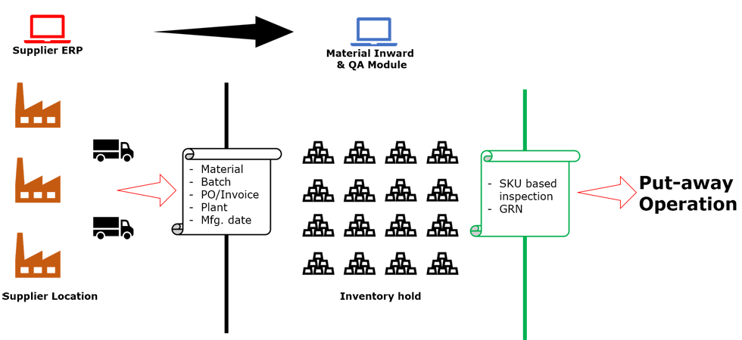

The application shall be designed to accommodate a robust material receipt and QA function which shall ensure that all incoming material is accounted for, identified and suspect material be weeded out.

Not all suppliers ship materials with barcodes making the job of material inward and QA all the more critical from an inventory accuracy and inventory traceability perspective.

The Material Inward & QA module shall be developed to accommodate all the challenges that are faced by managers in inward and material receipt operations.

This module shall ensure that every unit of inventory is individually tracked, identified with suitable markers (barcode, RFID, NFC, BLE, etc.) depending on the nature of products.

The Material Inward & QA module can be integrated with clients’ existing ERP packages.

### Put-Away [Enhancement]

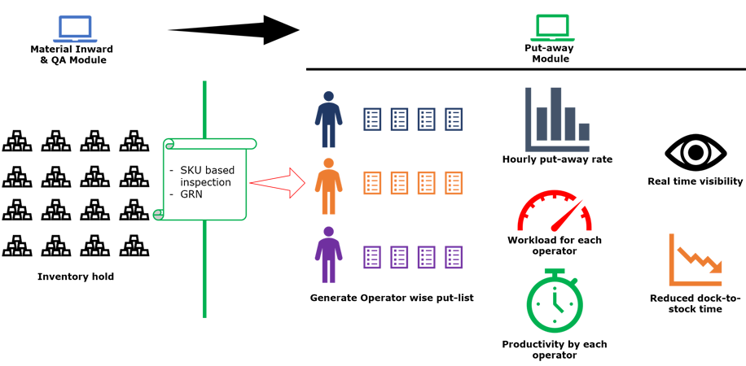

An efficient material receipt operations needs to be backed by a robust put-away operation.

Inventory awaiting put-way is simply inventory paid for but unavailable for servicing customer orders. So a timely and accurate put-away ensures all the inventory that is received is available for picking to reduce the overall dock-to-stock time.

The put-away module shall be developed to work either independently (in absence of WMS) so that it can generate put lists and track put-away progress or it can be integrated with the client’s existing WMS package to generate the put list. The put-away module shall track the progress of each item, thereby ensuring that the put-away operation is accurate, timely and error-proof.

The solution shall be designed to be user friendly and intuitive enabling the operator to start using it with very little training.

### PickingPicking

Picking is by far the most critical activity in warehousing operations. Quality of picking process, its speed and accuracy has a direct impact on customer satisfaction. A well-managed picking operation delivers the right product, at a right time, in right quantity to the right customer!

Verbat’s picking module shall be developed to digitize picking operations, eliminating paper documents and empowering every warehouse picker to seek information and send feedback in real time.

In addition to assisting the picker, the module shall allow warehouse managers to track work load by each picker, assign tasks and track activity progress in real time. Thereby eliminating every blind spot in every stage of picking activity and this improved visibility helps in predictability of picking operations.

The smart routing algorithm plan picking route to ensure efficient picking operation. The modules shall be designed to work either independently (in absence of WMS) or in integration with clients’ existing WMS/ERP package

### Packing [Enhancement]

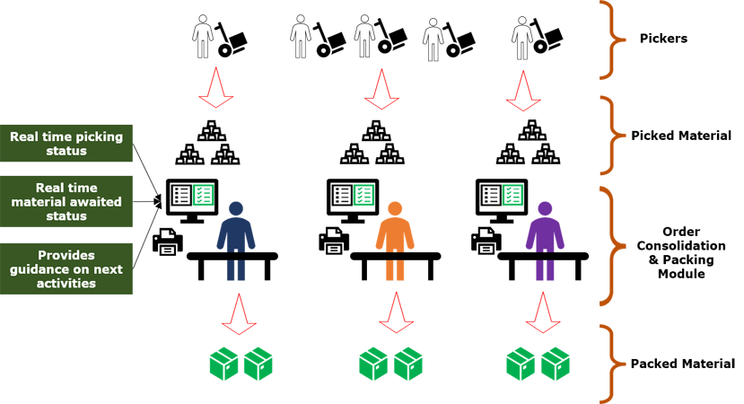

Orders are picked in a fashion that maximize warehouse picking efficiency. It is therefore customary that picking is done based on location rather than based on orders.

The packing and order consolidation teams are given clear and timely instructions to process items picked thereby ensuring there is no bottlenecking at packing and order consolidation.

The module has been designed to work either independently (in absence of WMS) where the module can generate shipment documentation or in integration with clients’ existing WMS/ERP package

### Dispatch [Enhancement]

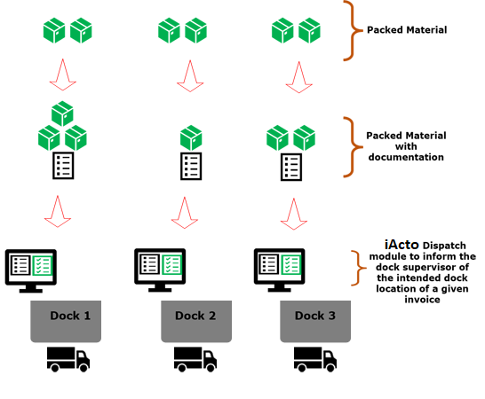

Dispatch is the last mile operation in a warehouse and plays a vital role in ensuring the efficiency achieved throughout the warehouse results in customer satisfaction.

The Packing & Order Consolidation module bridges the gap between picking and dispatch. It is critical that real-time picking status by order is shared with packing and order consolidation.

The packing and order consolidation teams are given clear and timely instructions to process items picked thereby ensuring there is no bottlenecking at packing and order consolidation areas.

The module is outfitted with a dock mapping feature that ensures that every package is delivered to the correct dispatch dock and loaded in the correct truck.

The module has been designed to work either independently (in absence of WMS) where the module can generate shipment documentation or in integration with clients’ existing WMS/ERP package.

## Application Workflow

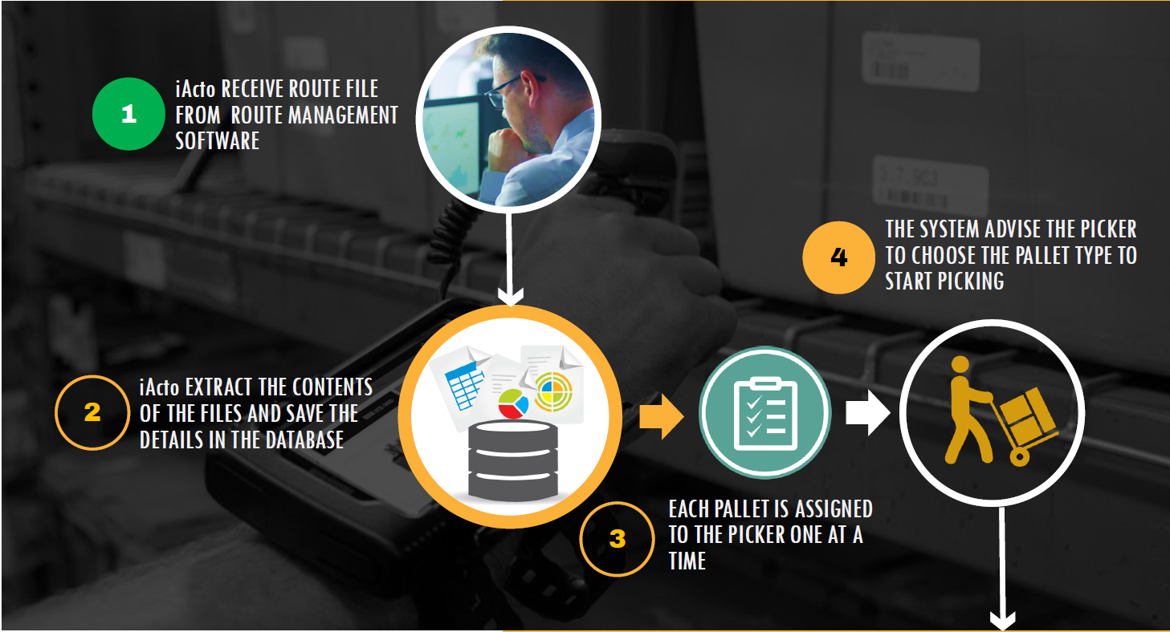

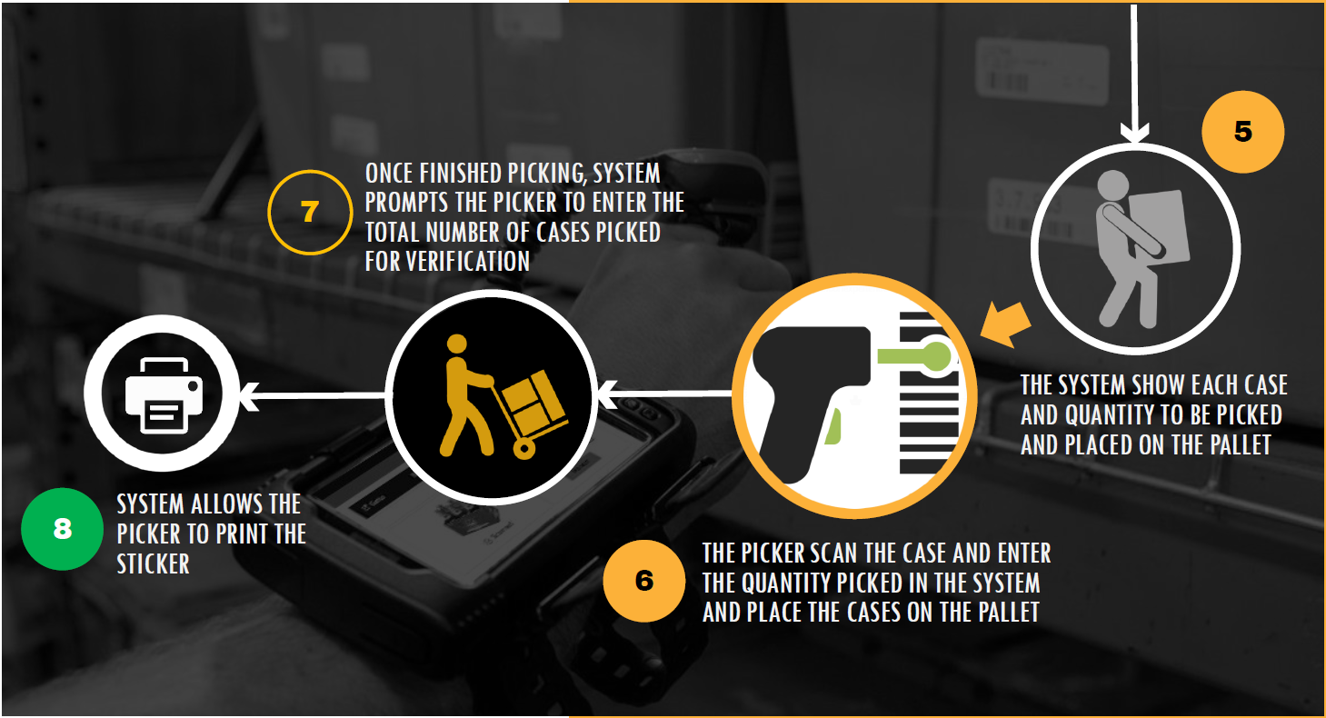

# Functional Requirements

The various modules present in the iActo system are as follows

* Admin – Manage users in the application
* Manager – Manage picker assignment
* Picker – Pick orders from the warehouse based on the assignments

The main features and functionalities of the application to be developed are presented below:

## Web Application

### Admin Module

#### Login

Admin user can log into the application by entering valid credentials (Username and Password). After inputting the credentials, the user has to click on the ‘Sign In’ button. On validation of the user login credentials, the user will be redirected to the Users page.

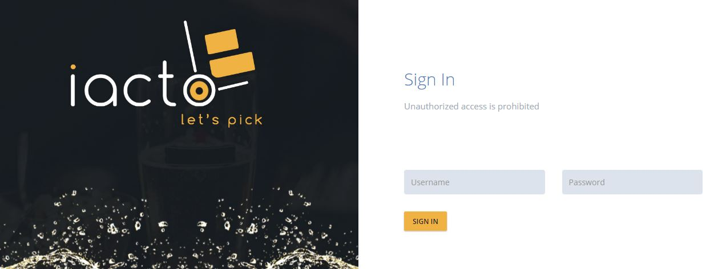

Figure: Admin Login Screen

The username and password are mandatory. If username or password does not match, then an error message, ‘Invalid username or Password’ will be displayed.

#### Users

‘Users’ is the default page in the Admin module of the application. On the Users page, admin can view the admin menu. Admin has the option to view and manage the users in the application.

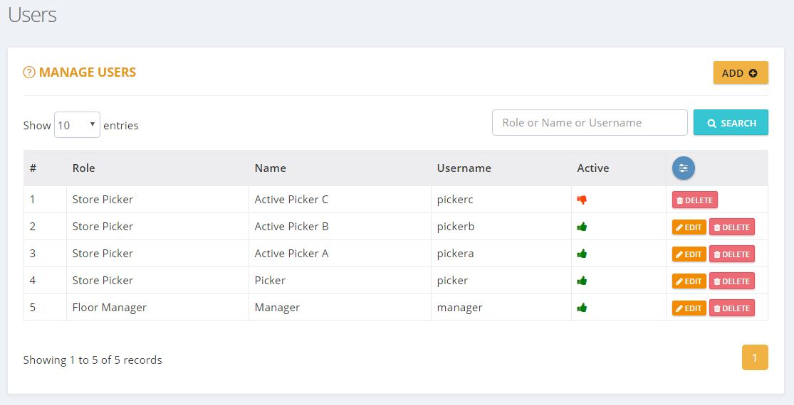

Figure: Users Screen

**Admin Menu:**

Admin can access the menu on the top right corner of the page. The menu include the options:

* Users
* Change Password
* Log Out

##### Manage Users

Manage Users page will list all the users in the application. The admin can also add/edit/delete user details. Admin user can search for users in this screen.



Figure: Manage Users Screen

The columns listed in the grid are:

* # – Serial number of the list.
* Role – Role type of the user
* Name – Name of the user
* Username – Username
* Active – The ‘thumbs up’ imageC:\Users\v10037\AppData\Local\Microsoft\Windows\INetCache\Content.Word\active2.jpgdenotes active users whereas the ‘thumbs down’ image C:\Users\v10037\AppData\Local\Microsoft\Windows\INetCache\Content.Word\inactive2.jpgdenotes inactive users. Inactive users will not be shown anywhere in the application other than ‘Manage Users’ screen.
* Actions 3 – It has two options - Edit and Delete.
  + Edit iconEdit_Iconagainst each user can be used to edit the user details.
  + Delete icon Delete_Icon against each user can be used to delete the user details.

There will be a ‘paging’ option, if there are more than 10 rows in the grid.

##### Add User

The Manage Users screen allows the admin to add users. Admin can add a user by clicking ‘ADD’ button on the right side. The admin will then be redirected to ‘Add User’ page.

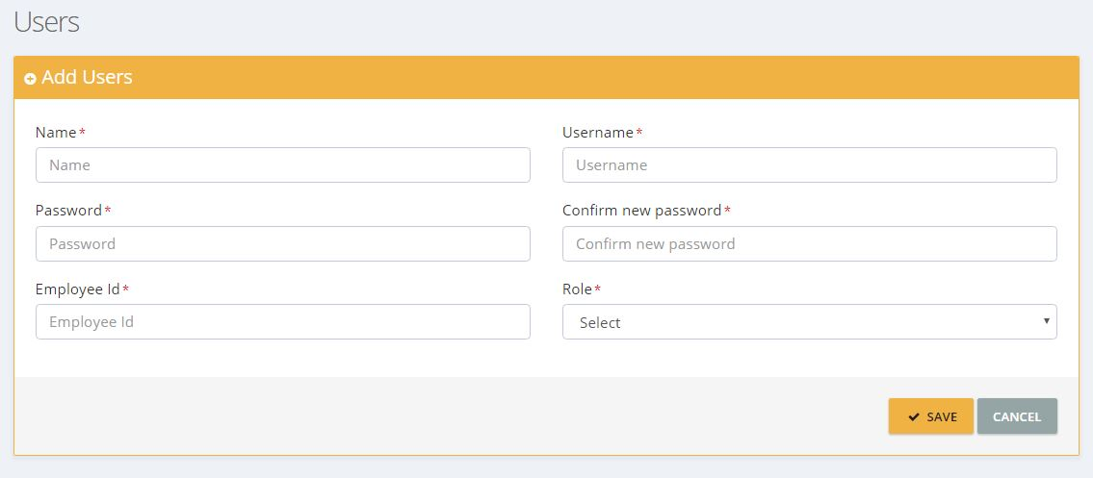

Figure: Add User Screen

Admin can enter the following user details:

* Name
* Username
* Password
* Confirm Password
* Employee ID

After entering all mandatory fields, admin can save the details by clicking ‘SAVE’ button. A message denoting ‘user added successfully’ will then be displayed on screen.

##### Edit User

The admin can edit the user details by clicking the edit iconEdit_Icon. The admin will then be redirected to ‘Edit Users’ page.

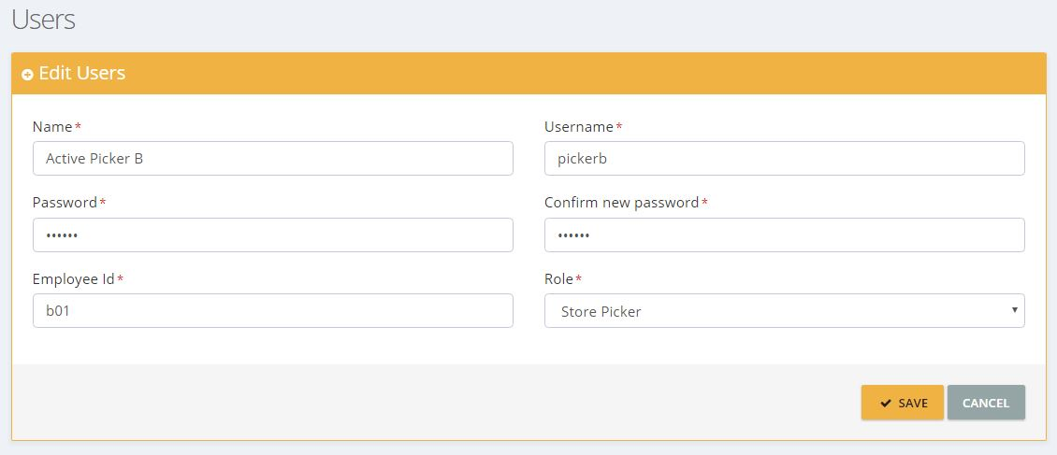

Figure: User Edit Screen

Here the admin can edit and update the user details. The admin can save edited details by clicking ‘SAVE’ button.

##### Delete User

The admin can delete a user by clicking the delete iconDelete_Icon. A popup will then be shown to confirm. Upon confirmation, the user details will be deleted from the system.

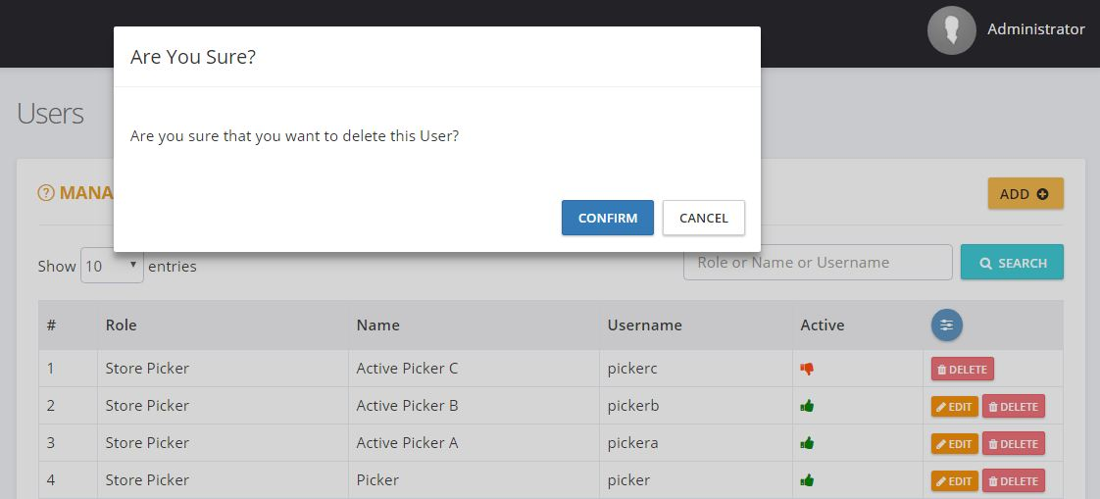

Figure: Delete User Screen

#### Change Password

Admin has the option to change current admin password in the application by using ‘Change Password’ option. On clicking the ‘Change Password’ option, the admin will be redirected to ‘Change Password’ page with the following fields:

* Current password
* New password
* Confirm password

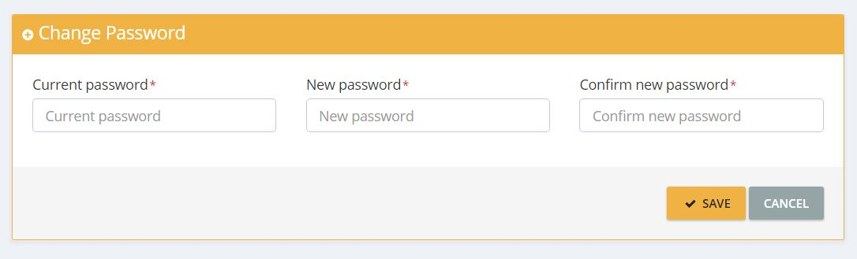

Figure: Change Password Screen

Admin can click ‘SAVE’ button after entering the above details. ‘New password’ and ‘Confirm password’ should be same and valid. The system will verify both new and old passwords, and will update the new password. If verification fails, an error message ‘Invalid Current Password’ will be displayed. On clicking the ‘Cancel’ button, the system will redirect the admin to ‘Manage Users’ page.

#### Logout

Admin can exit the application by clicking the ‘Logout’ option. The log-out link will redirect the admin to the ‘Login’ screen.

## Mobile Application

### Users

#### Manager

Manager module is used to manage the picker assignment. The manager user is created by the admin.

Manager can manage contents of the application with the following features:

* Manage picker assignment.
* Reset picker password.

##### Login

Manager user can log into the application by entering valid credentials (Username and Password). After inputting the credentials, the user has to click on the ‘Sign In’ button. On validation of the user login credentials, the user will be redirected to the Manager Dashboard page.

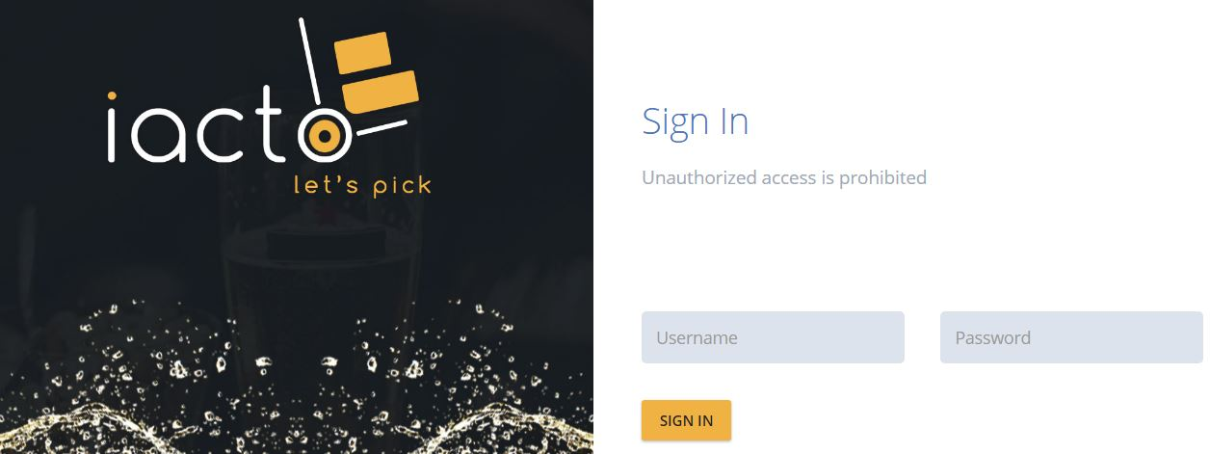

Figure: Manager Login Screen

The username and password are mandatory. If username or password does not match, then an error message, ‘Invalid username or Password’ will be displayed.

##### Manager Dashboard

On the Manager dashboard, managers can view the number of routes received, number of routes completed, number of assignments received, number of assignments completed, number of pending cases to pick, assignment status graph, top orders graph, route status graph and ‘Today’s Top 2 Pickers’ graph. Managers get the options ‘assign to picker’ and ‘reset picker password’.

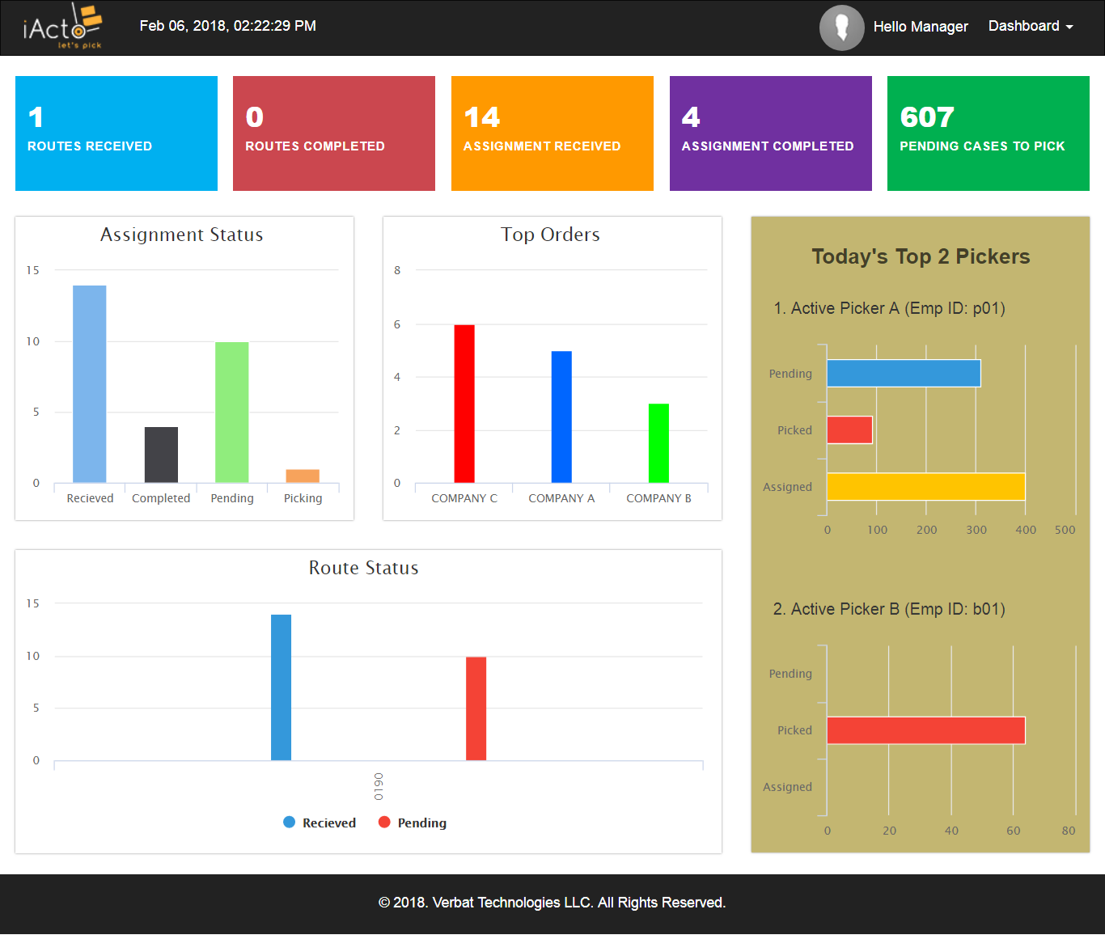

Figure: Manager dashboard Screen

Manager can view the current assignment status of a particular day with the help of ‘Assignment Status’ graph. ‘Top Orders’ graph represent the top five companies that have placed orders based on quantity. A maximum of 35 current routes status details are represented in the route status graph. Current date’s top two pickers are displayed in ‘Today’s Top 2 Pickers’ graph.

**Manager Menus:**

Manager can access the menu by clicking ‘Dashboard’ tab on the top right corner. The menu includes:

* Assign to Picker
* Reset Picker Password
* Change Password
* Logout

##### Assign to Picker

By clicking the ‘Assign to Picker’ option from the ‘Dashboard’ tab menu, the user will be redirected to ‘Assign to Picker’ page. Manager can view all active assignments (Previous date/current date) listed in ‘ASSIGN TO PICKER’ table.

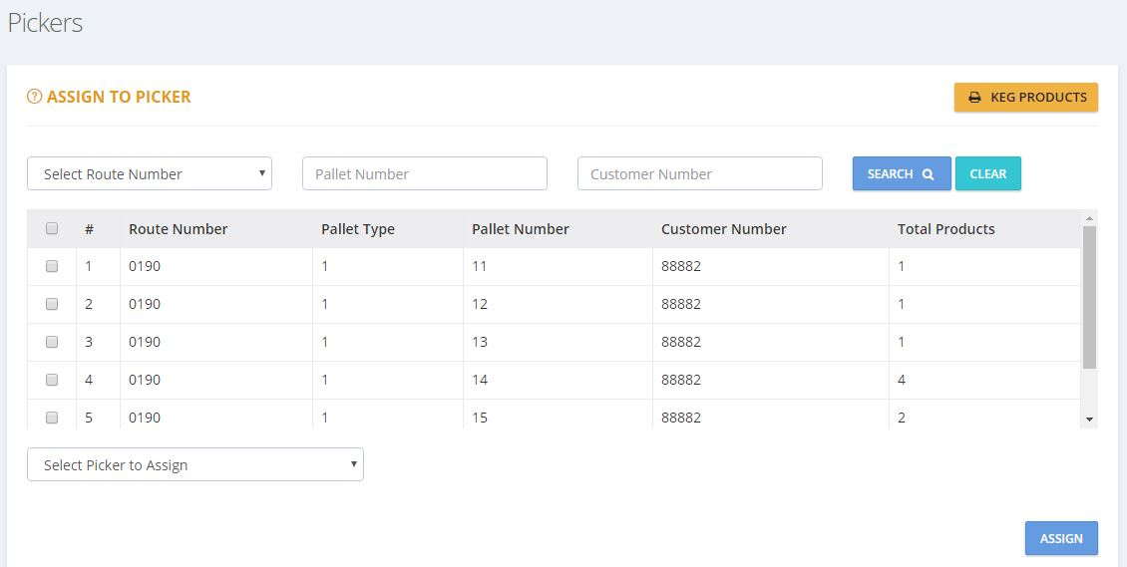

Figure: Assign to Picker Screen

Manager can view ‘Assign to Picker’ page with the following fields:

* Select Route Number
* Pallet Number
* Customer Number
* Select Picker to Assign

The columns listed in the grid are:

* Checkbox
* #
* Route Number
* Pallet Type
* Pallet Number
* Customer Number
* Total Products

Manager can select assignments (all/selected) from ‘ASSIGN TO PICKER’ table, and assign them to a particular picker listed in the ‘Select Picker to Assign’ dropdown field. On clicking the ‘ASSIGN’ button, the selected assignment shall be assigned to the particular picker and a ‘successful assignation’ message will be displayed on the screen. If not, an ‘assignation failure’ message will be displayed. The assignment assigned to a particular picker will not be listed in the ‘Assign to Picker’ table, and cannot be viewed by other pickers. Manager can also search assignments with the help of Select Route Number/Pallet Number/Customer Number fields.

##### Reset Picker password

The manager can use this option to reset the current picker password.

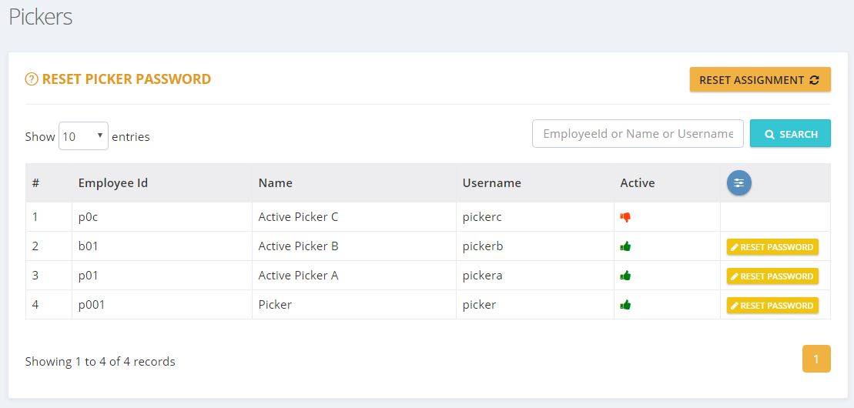

Figure: Reset Picker Password Screen

By clicking the Reset Picker Password option from the ‘Dashboard’ tab menu, the user will be redirected to ‘Reset Picker Password’ page. Managers can view all active and inactive pickers which will be listed in RESET PICKER PASSWORD table. On clicking the ‘RESET PASSWORD’ button of the particular active user from the RESET PICKER PASSWORD table, the user will then be redirected to ‘Reset password here’ page with the following fields:

* New password
* Confirm new password

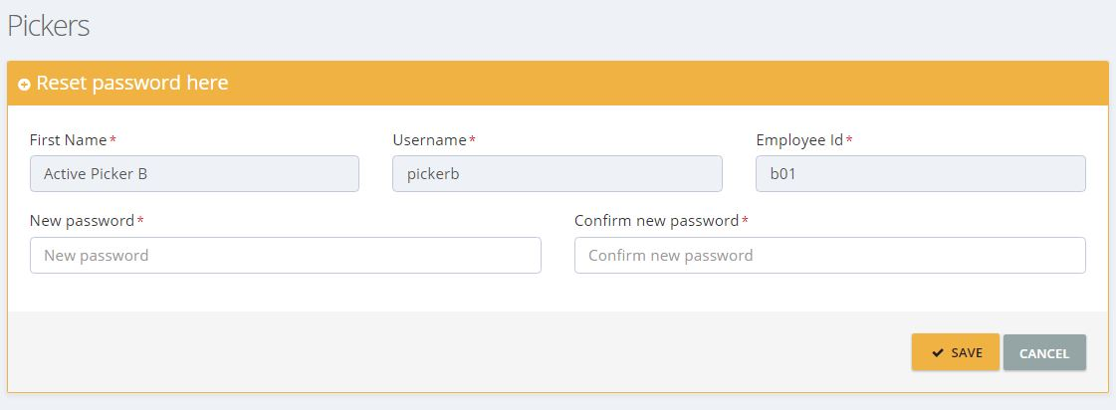

Figure: Reset Password here Screen

Manager can click ‘SAVE’ button after entering the above details. ‘New password’ and ‘Confirm new password’ should be same and valid. The system will verify both ‘new’ and ‘confirm new’ passwords, and will update the new password.

##### Change Password

Manager has the option to change current manager password in the application by using ‘Change Password’ option. On clicking the ‘Change Password’ option, the user will be redirected to ‘Change Password’ page with the following fields:

* Current password
* New password
* Confirm new password

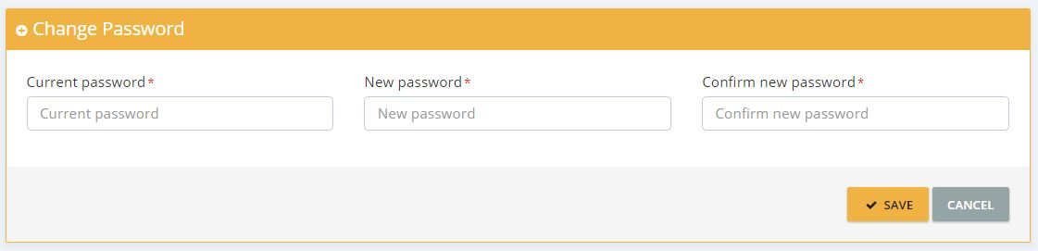

Figure: Change Password Screen

Manager can click ‘SAVE’ button after entering the above details. ‘New password’ and ‘Confirm new password’ should be same and valid. The system will verify both new and old passwords, and will update the new password. If verification fails, an error message ‘Invalid Current Password’ will be displayed

##### Logout

Manager can exit the application by clicking the ‘Log Out’ option from the menu. The log-out link will redirect the user to Login screen.

#### Picker

Picker user can pick orders from the warehouse based on the assignments he received on the mobile app.

##### Login

Picker can login to the mobile application by entering valid credentials (Username and Password). After inputting the credentials, the user has to tap the ‘Sign In’ button. On validation of the user login credentials, the user will be redirected to the ‘Profile’ page.

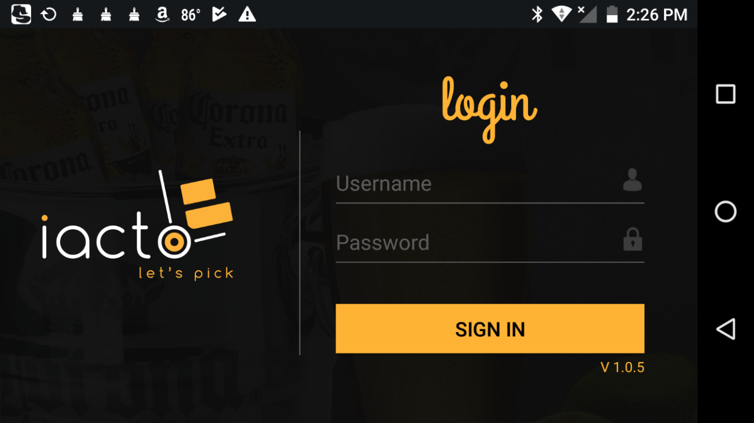

Figure: Login Screen

If username or password does not match, then an error message, ‘Invalid username or Password’ will be displayed.

##### Profile Screen

On the ‘Profile’ screen, the picker can view his/her profile. The picker can also set new profile picture.

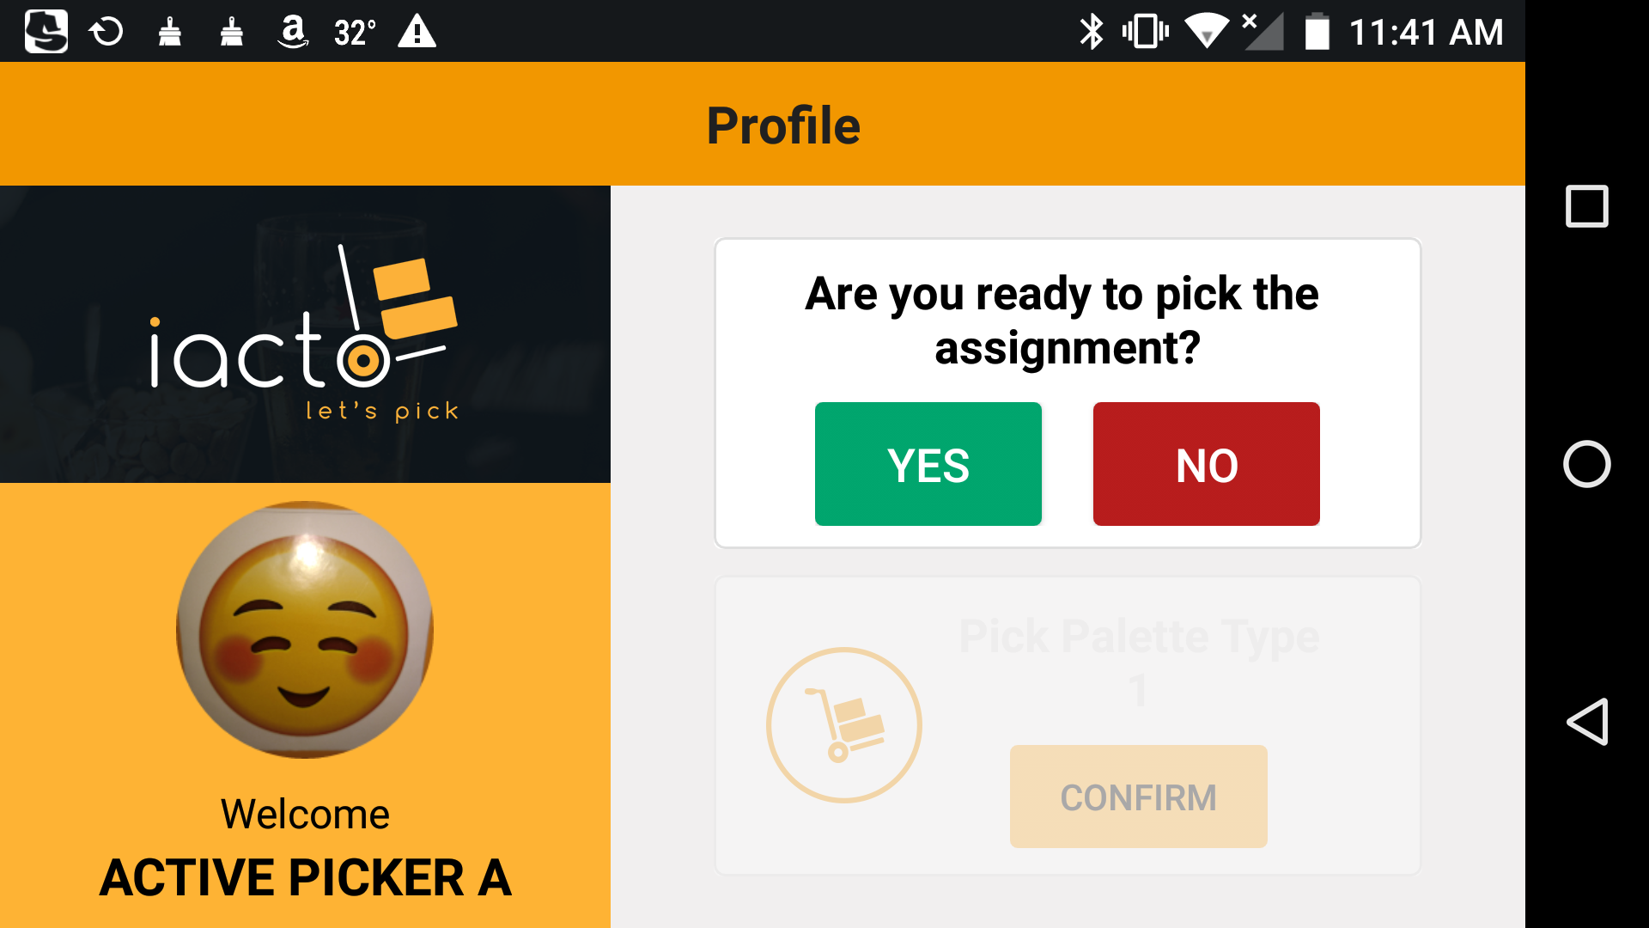

Figure: Profile Screen

If the picker is ready to pick an assignment, he/she has to tap the ‘YES’ button. The picker would then be able to view the allocated pallet type with a ‘Confirm’ option. If there is no assignment available, a popup message displaying the same will be displayed.

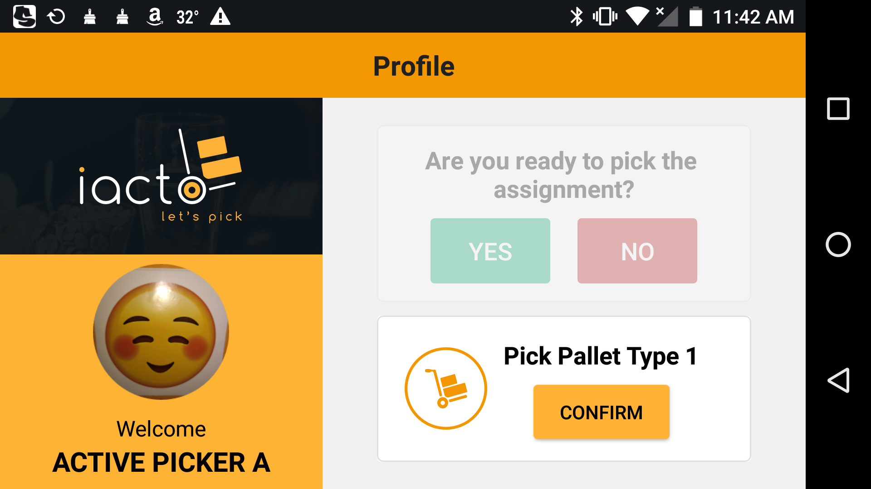

Figure: Profile Confirm Screen

If the picker taps on the ‘CONFIRM’ button, the page will be redirected to ‘Product Scanning’ page.

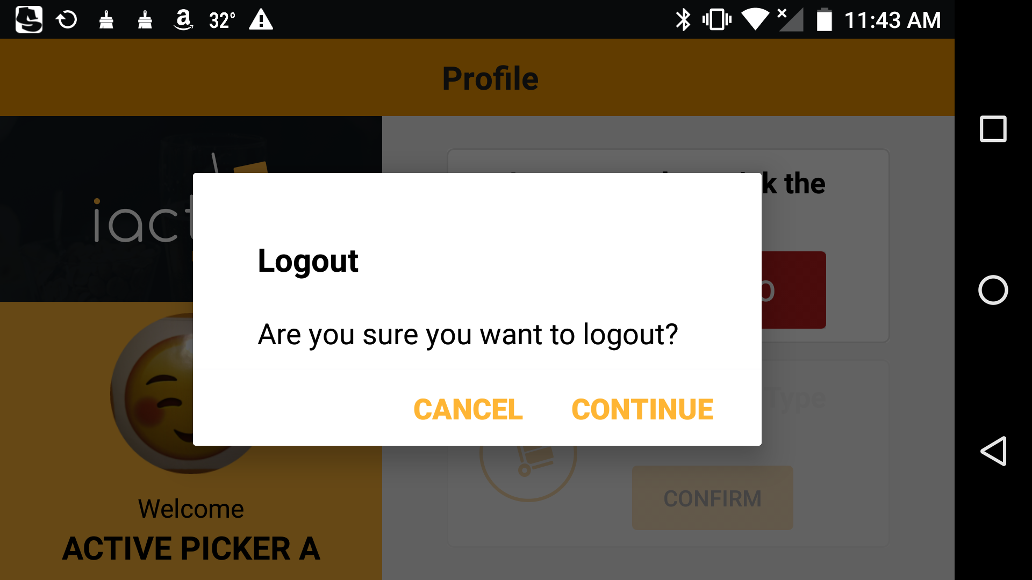

Figure: Profile logout Screen

If the picker taps on the ‘NO’ button, a popup message will be displayed with log-out option. By tapping on the ‘CONTINUE’ button, the picker can log out of the application.

##### Product Scanning

On the ‘Product Scanning’ page, pickers can view the location, quantity of the product that needs to be picked, the name of the product with image, and a ‘skip’ option. In order to scan the product, the picker uses a finger scanner connected to the device via Bluetooth.

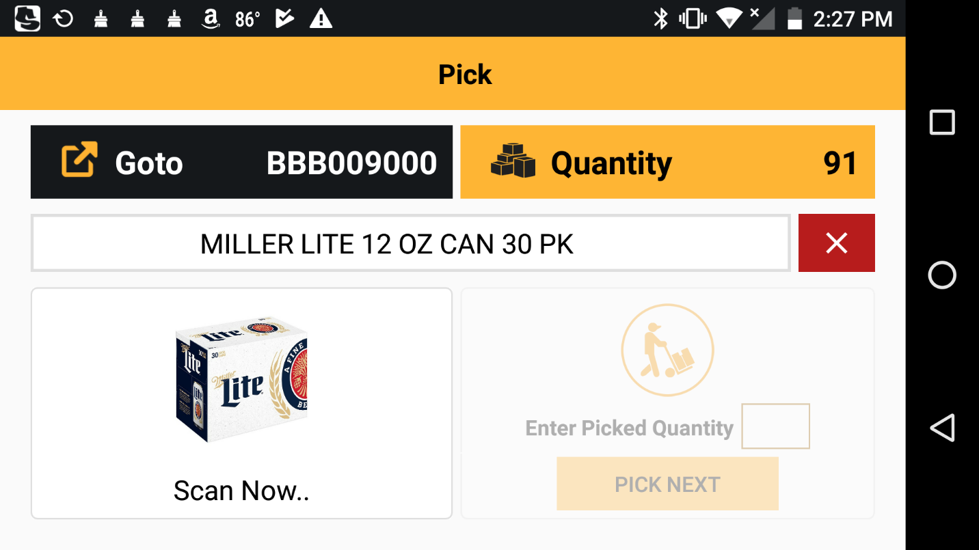

Figure: Product Scanning Screen 1.1

Once the product barcode is scanned and it matches the assigned barcode, the ‘Scan Now’ changes to ‘Scanned’, and the product pick option (‘Pick Next’) will be active. In the product pick option, the picker can enter the picked quantity and confirm the same by tapping ‘Pick Next’ button.

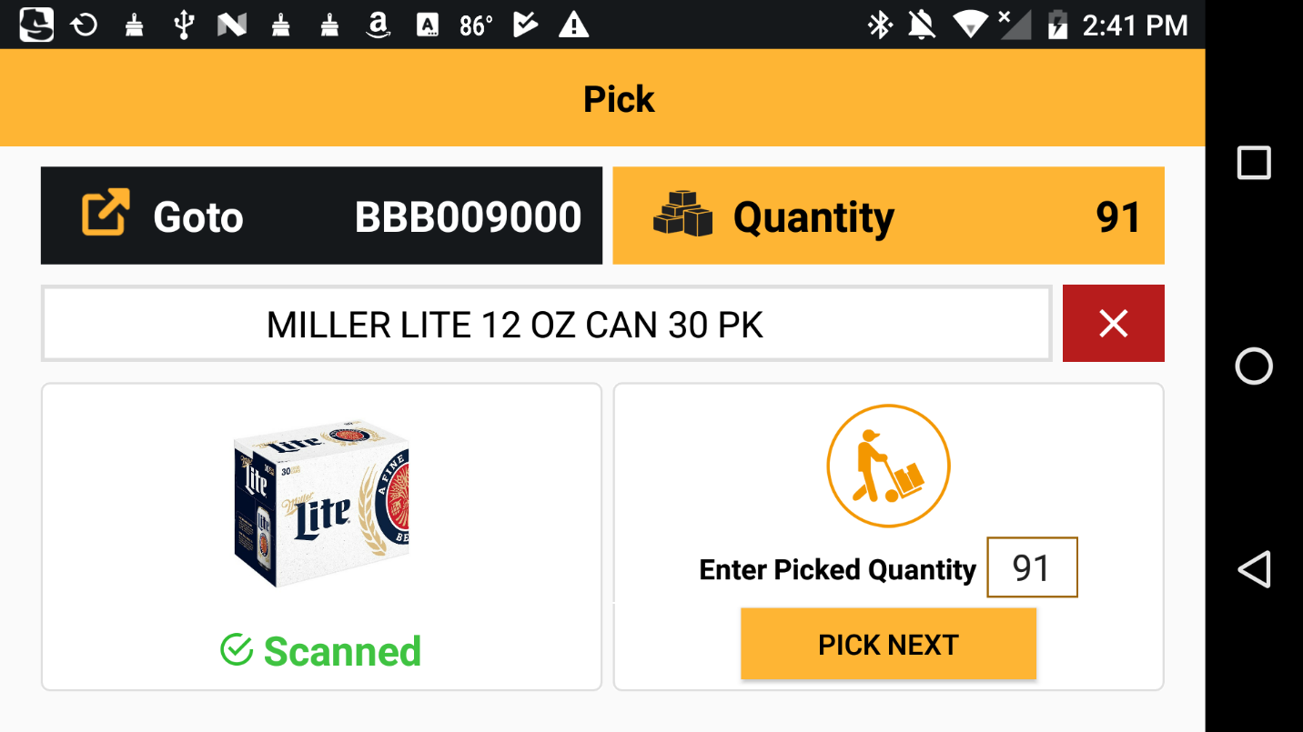

Figure: Product Scanning Screen 1.2

If the entered ‘picked quantity’ does not match the assigned quantity, a ‘mismatch’ popup message will be displayed.

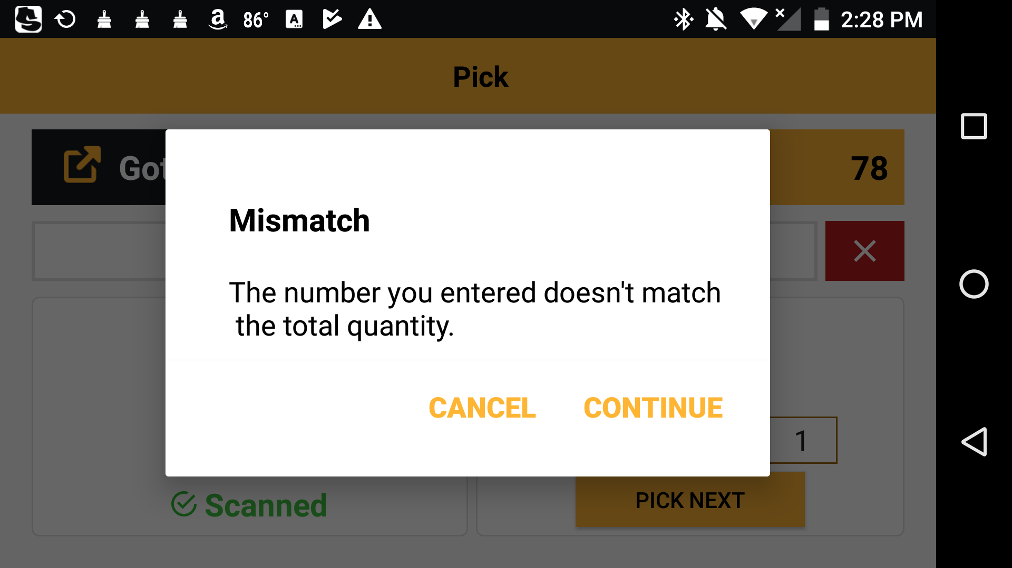

Figure: Product Scanning Screen 1.3

By tapping the ‘CONTINUE’ button in the mismatch popup message, a new page is displayed where the total number of cartons picked is to be entered. Then the user needs to tap the ‘NEXT’ button.

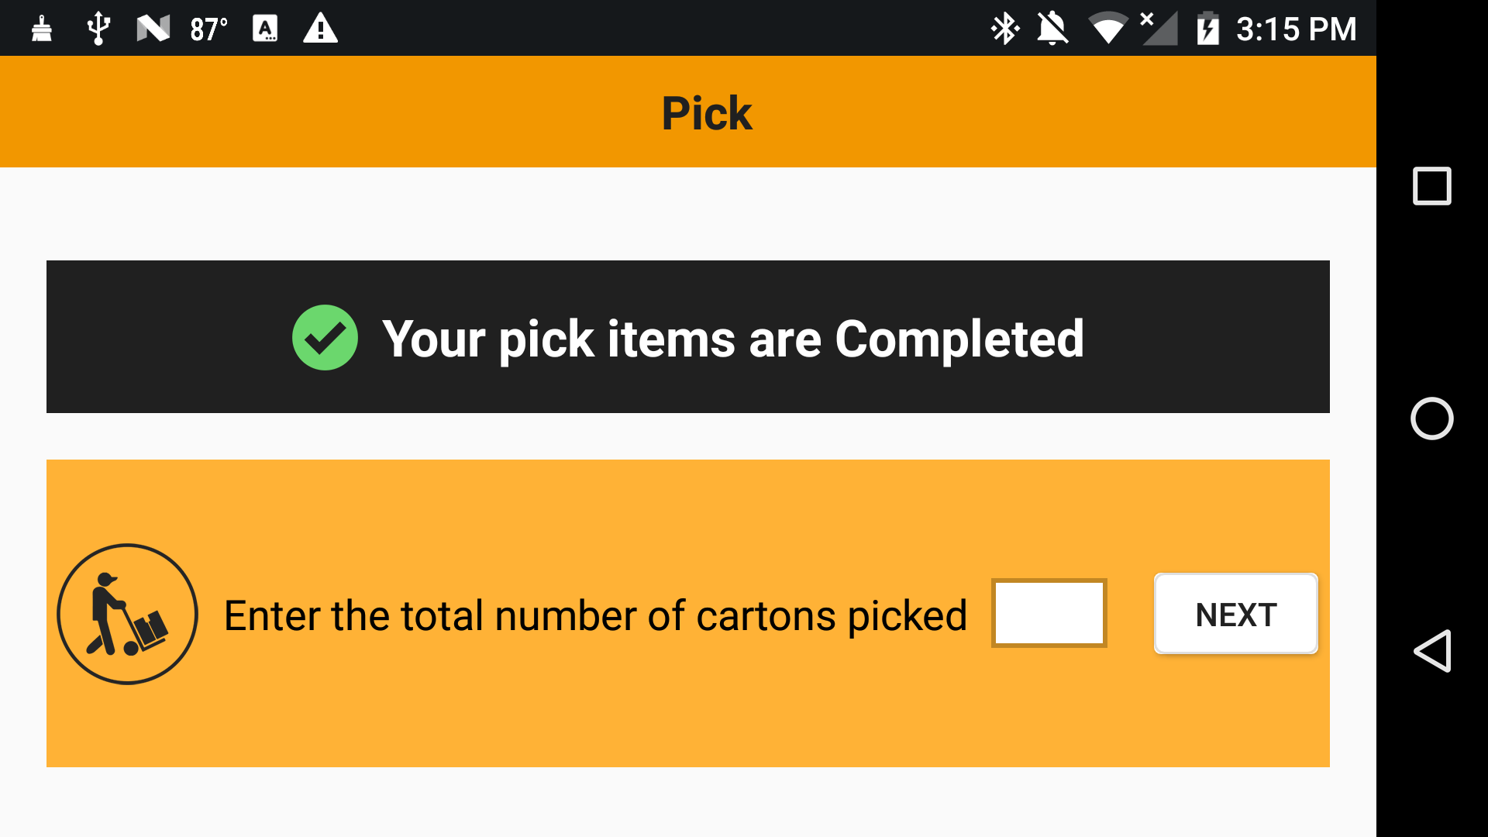

Figure: Product Scanning Screen 1.4

If the entered quantity matches the picked quantity, a popup message stating ‘Your assignment is COMPLETED’ is displayed. In addition, this popup window also provides an option to print packing sticker.

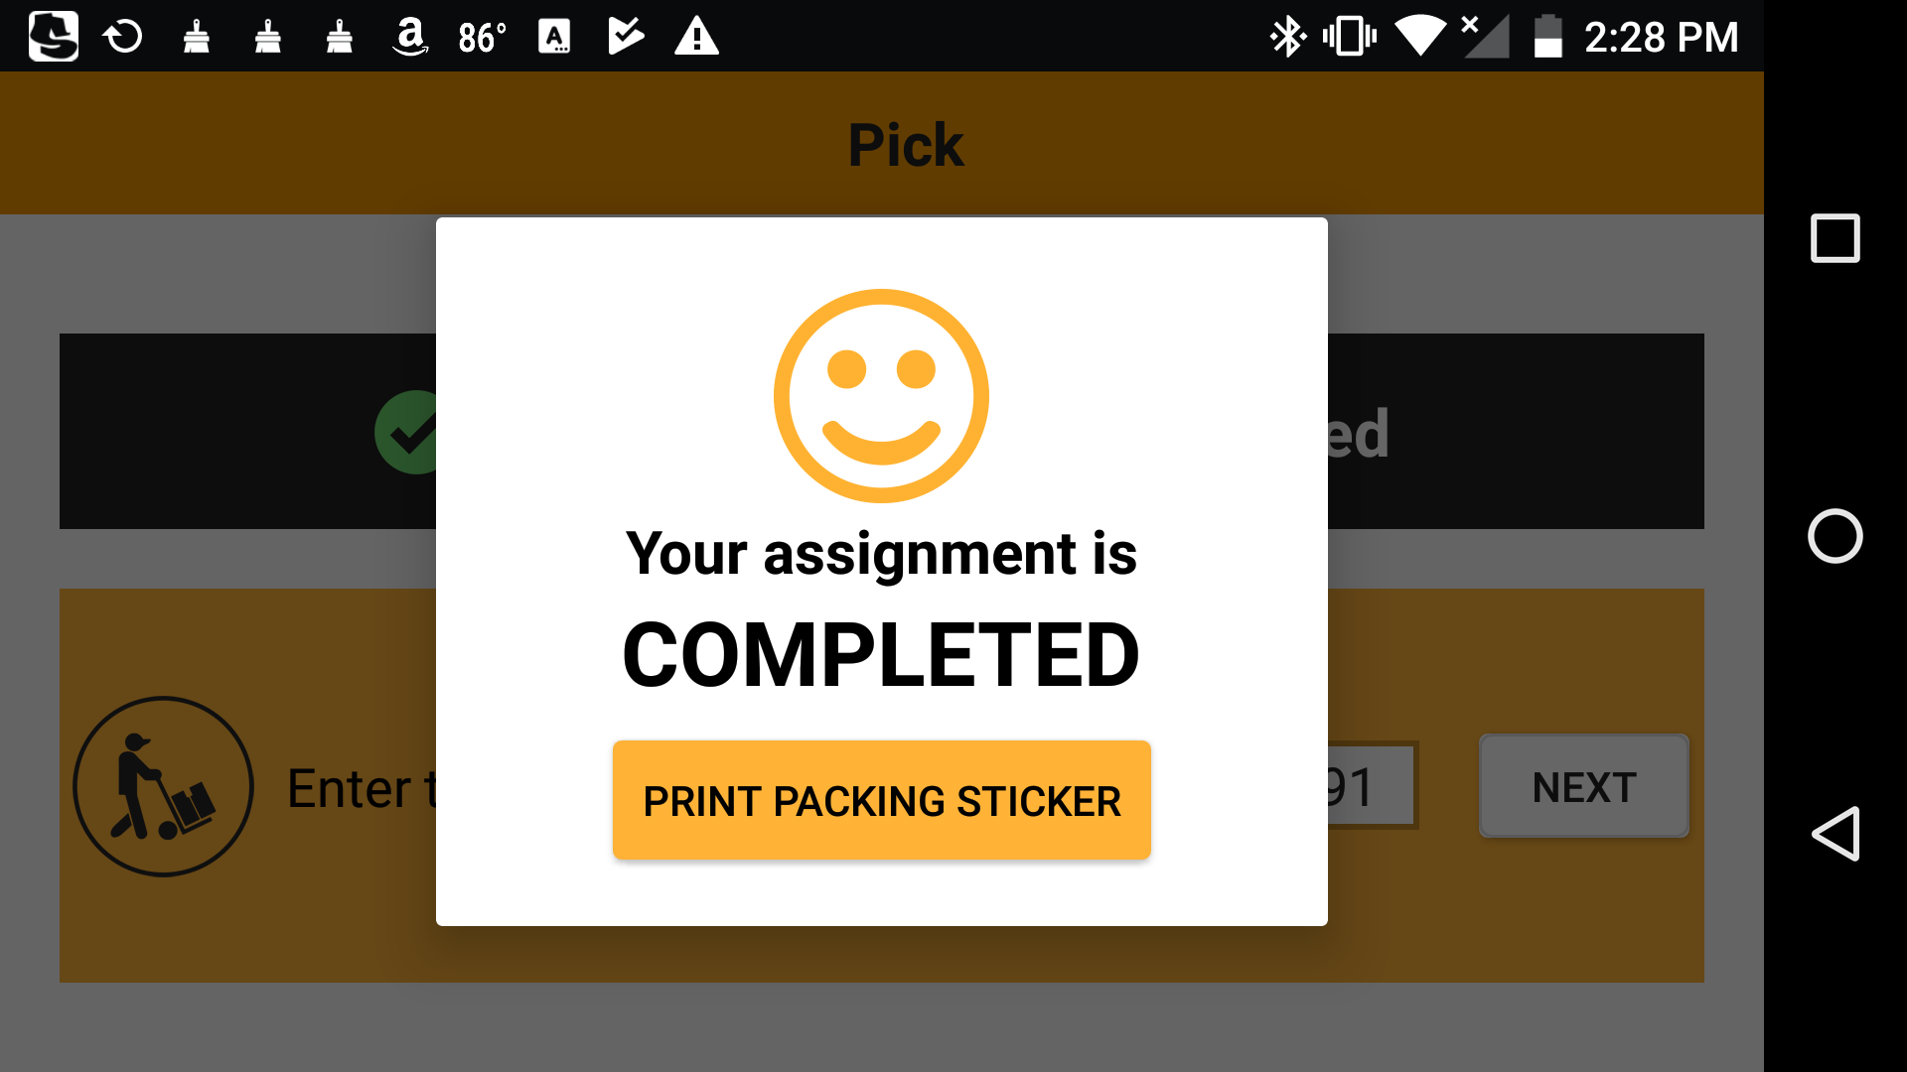

Figure: Product Scanning Screen 1.5

Once the assignment is completed, the user will be redirected to the ‘Profile’ page.

If the entered quantity does not match the picked quantity, a mismatch popup message will be displayed. In addition, this popup window also provides an option to retype the quantity.

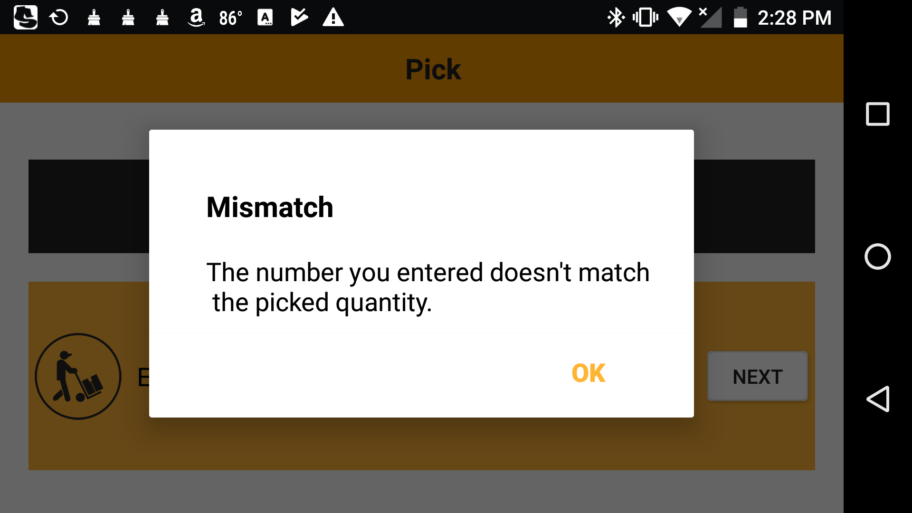

Figure: Product Scanning Screen 1.6

If the picker did not pick the assigned quantity completely and entered the respective picked quantity, then the entered quantity would be a mismatch with the ordered quantity. A mismatch popup message will then be displayed. In addition, this popup window also provides an option to contact the Floor Manager.

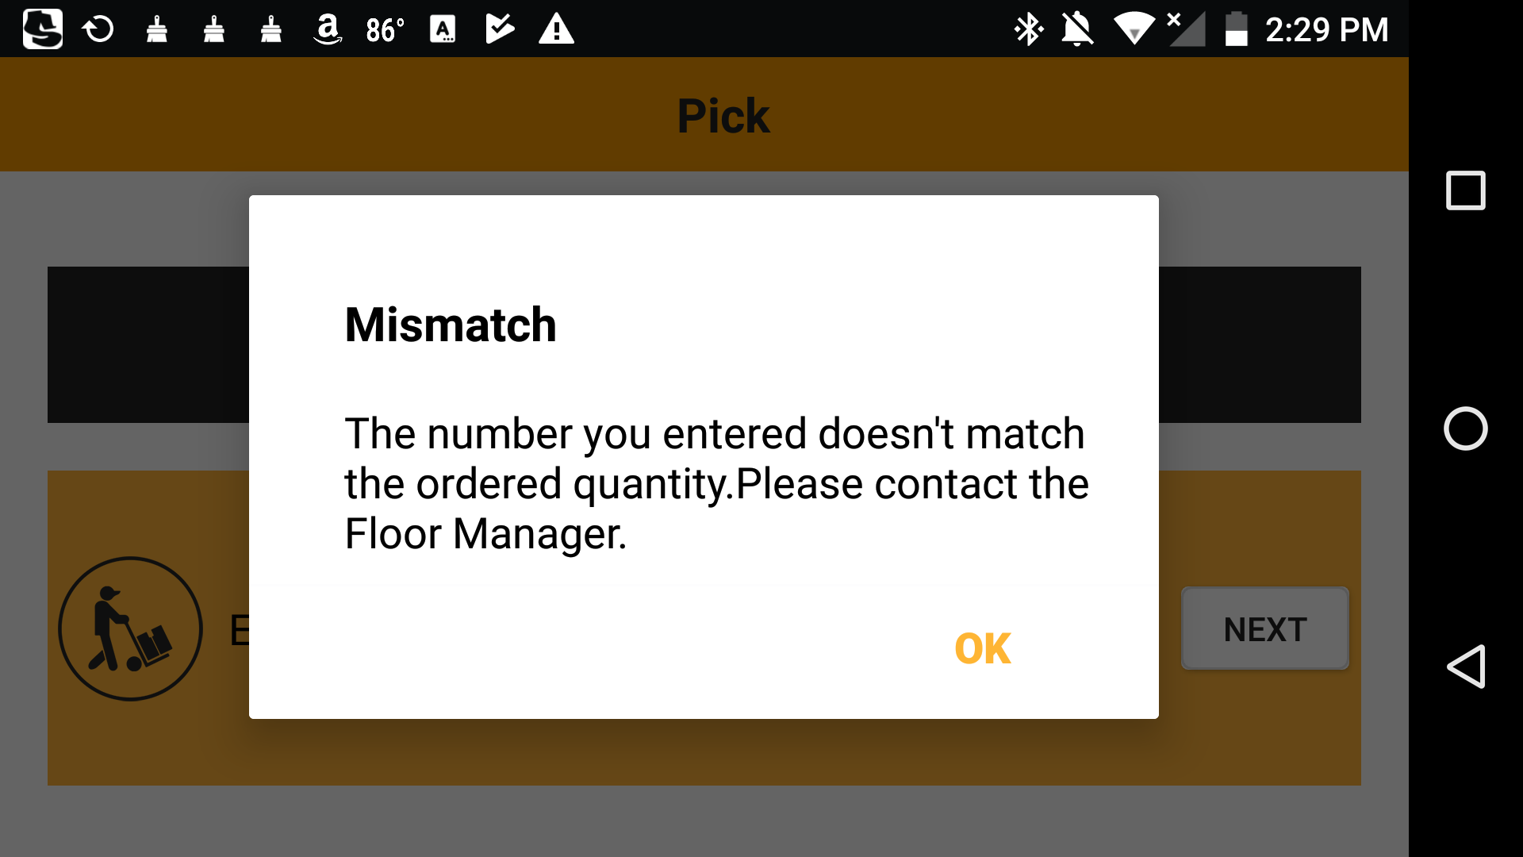

Figure: Product Scanning Screen 1.7

On tapping the ‘OK’ button, the Floor Manager Confirmation popup window will be displayed. Picker can continue this assignment with the help of the Floor Manager. Floor manager should provide login credentials and continue the assignment by touching ‘CONTINUE’ button.

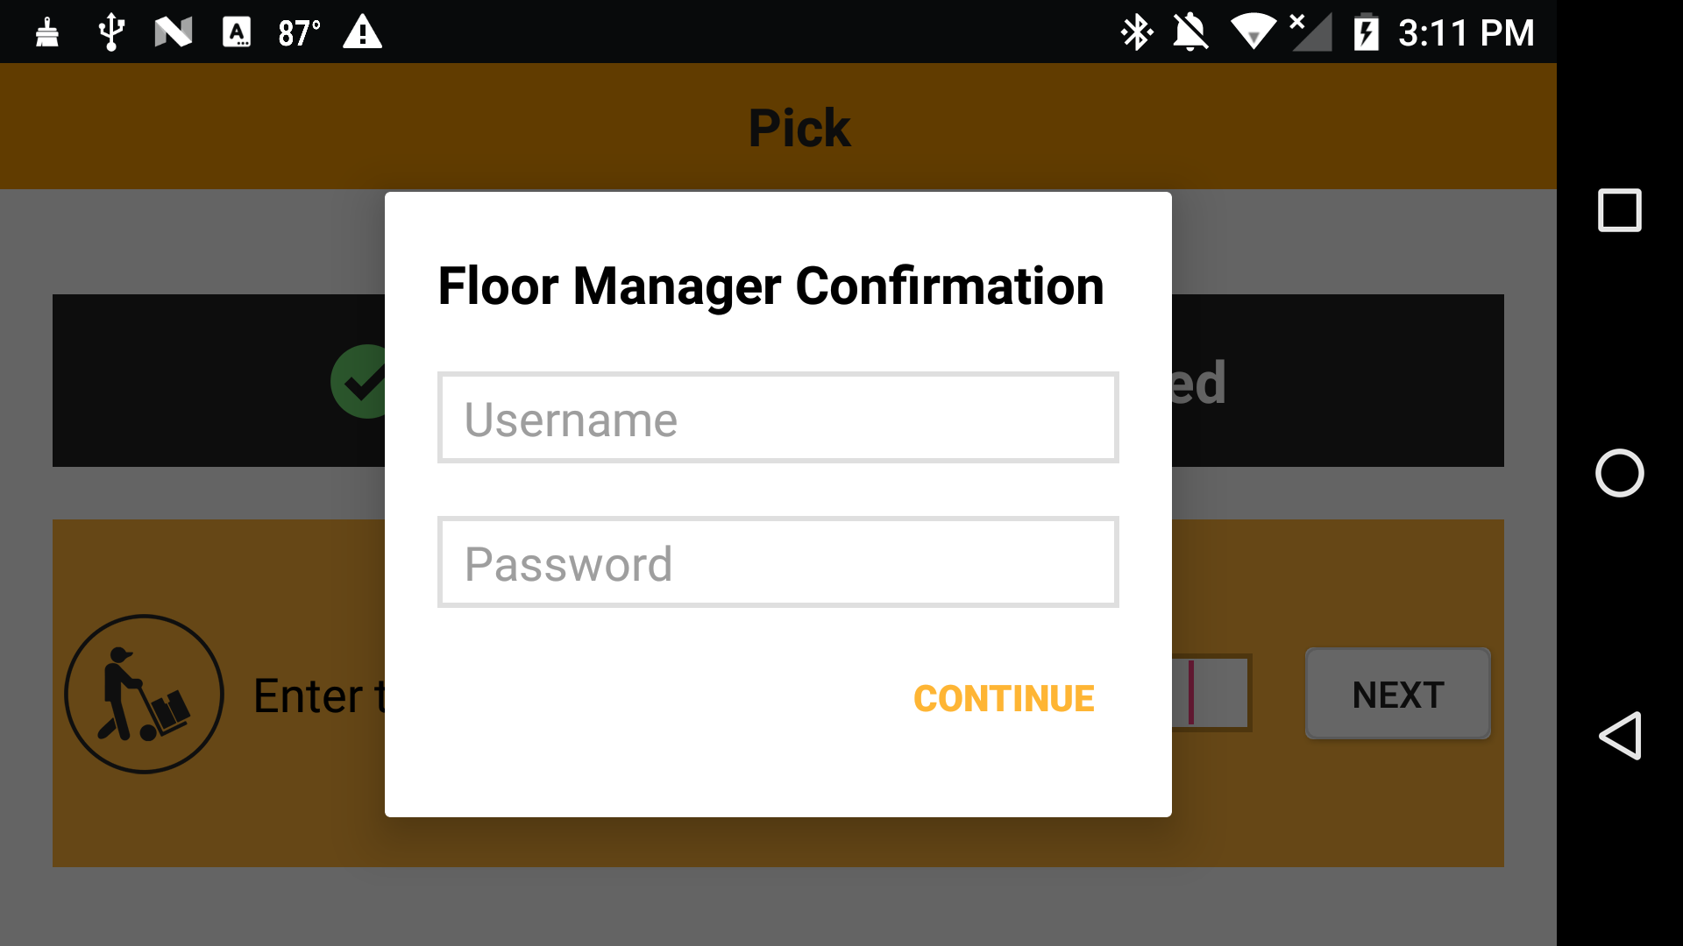

Figure: Product Scanning Screen 1.8

Finally, if the entered Floor Manager login credentials are valid, a popup message stating that ‘Your assignment is COMPLETED’ will be displayed, and an option to print packing sticker is provided.



Figure: Product Scanning Screen 1.9

*Note:*

*The features and functionalities discussed above have been derived based on the initial product design.*

|  |  |
| --- | --- |
| **Requirements** | **Details** |
| User Experience and  UI Design | * The application will be developed only in English * The layout and graphical components will be created considering the usability factors |
| Performance | * Application will allow users to have smooth and quick access to the information or services they require. |
| Security | * Web security standards will be followed. |
|  |  |

## Web Services

### Print Services

Verbat shall create a print service for iActo. The print Service routes all print jobs from the handheld devices to a print queue. The documents shall be de-queued and printed using preconfigured network printers

# Non-Functional Requirement

## Proposed System Environment

****

ASP.Net, MVC

, Android SDK

HTML5 / CSS3

Java Script

Windows

IIS

MS SQL

Android

**MS SQL2012  
Windows 8/10  
Web Services**

## Technical Configurations

### Development Tools

* C#, ASP.Net 4.5 /Android Studio/Java
* MS SQL
* HTML / CSS 3
* Photoshop
* Web services, Ajax, JavaScript

### Recommended Web Hosting Package- Dedicated

#### Hosting

* Operating System : Windows Server
* CPU : 2 core
* Domains: Unlimited
* Disk Space: 200 GB
* Monthly Bandwidth: 50 GB
* Web site Server Software – IIS 7.5 +
* ASP.NET 4.5

### Browser

The application developed shall be compatible with the browsers listed below:

1. Internet Explorer 11
2. Mozilla Firefox 50 or above
3. Chrome 50 or above

### Hardware Devices

#### Mobile device with the following specs

* The mobile app should be compatible with the android KitKat and above
* The mobile app should support 5.2 inch screen
* The Bluetooth version should be 4.1 and above
* The device should support LTE / Wi-Fi 802.11 a/b/g/n/ac
* The device should have 3 GB RAM and above memory

#### Scanner

Verbat suggest to rather use ‘Symcode’ Bluetooth ring scanner than other Bluetooth scanners.

#### Printer

Verbat suggest to use printers configured with A6 paper size.

#### Web Server

We recommend the specification mentioned below for the best output.

* Microsoft Windows XP Professional SP3/Vista SP1/Windows 7 or 8 OS
* Processor: 2.6 GHZ Intel Pentium IV or equivalent
* Memory: 2GB
* Disk Space: 1 GB of free disk space

### Technical Standards

* Screen Resolutions

*1080 x 1920, 720 x 1280, 750 x 1334, 640 x 1136*

* Testing Devices

*Google Pixel     Android 7*

*Motorola Moto G Turbo Edition -   Android 6*

* OS Version

*Android KitKat and above*

### Technical Guidelines

The guidelines provide instructions and conditions that will be adhered to during the development of the mobile application.

* API will be used, as the case may be, in realizing the features and functionalities mentioned
* The client will finalize the functional requirements and UI/UX before the commencement of the project
* Verbat will be testing the app in the mentioned devices only. Testing on devices other than the ones mentioned under the “Technical Standards “ will have to be specified and provided by the client at the beginning of the development phase
* The client will have to provide the details of the testing devices they are using before the start of development phase
* Client **should** provide the relevant Developer's Account credentials before the development phase. In case Verbat needs to create the developer id additional charges will be incurred by the client
* The duration mentioned in the project time line is for development and testing and any delay or time taken by the review team to respond will not be Verbat’s responsibility
* Any clarification required from client needs to be addressed within 24 hrs.
* The apps will be developed / created within the guidelines of Android play store.
* Verbat will strictly follow the guidelines provided by the respective stores.
* Verbat will inform the client if any of the client requirements / request deviates from it.
* Customization of the features of the app will be susceptible to the limitation imposed by the respective platform/ store.
* Once development commences the test device/screen sizes will not be susceptible to change. Any change requested by the client will have to go through change management
* OS version support will be limited to the ones mentioned in the technical specifications. Further support will have to go through change management

## Project Delivery

### Project Management

The Verbat development center strictly follows industry standards on quality. The project management is process governed by the Verbat Quality Management system and is put to verification through internal audit programs that happen from time to time. Verbat will dedicate a project manager for the proposed implementation. Verbat proposes Client to identify one project manager who will be driving activities to be undertaken by Client to be the single point of contact for Verbat.

### Roles & Responsibilities

Verbat will assign a dedicated Project Manager/Project Lead to lead the project, who will be the first point contact for Client. He/she will be responsible for planning and managing the various activities within the project. He/she will work closely with Client Project Manager, to give periodic status updates and ensure high level of visibility and comfort on the progress of the project. The Project Manager/Project Lead will lead the co-ordination between Verbat and Client, thus enabling smooth transitioning of Client requirements to the Verbat ’ offshore delivery team, and provide visibility as well as comfort on the progress of the services to Client.

He/she will have periodic meetings with Verbat ’ Senior Management, thus ensuring Verbat ’ Management commitment and focus on Client initiatives.

### Delivery Activity Summary

|  |  |
| --- | --- |
| Activities | Description |
| Detailed requirement Analysis | Verbat team to conduct detailed study of requirement for the phase. If clarification is required, team will reach out to Client for more information and/or time for discussions. |
| DB Design | DB design for central and test DB. |
| Software Requirement Specification document (SRS) | Once the requirement analysis is completed, Verbat team will submit the SRS document for approval |
| UI/UX Design, Prototyping | Based on the SRS, Verbat UX/UI team will work on the UI/UX of the screens and submit for approval |
| Functional Specification Document (FS) | Once the UI/UX is approved, Verbat shall submit an FS document for approval. |
| Development | Actual system development starts based on the FS. This involves detailed design and software development of Web Application. |
| Testing | Test Planning, test plan creations, internal, integration testing and user acceptance testing. |
| Deployment | Deploying the latest built in the Verbat Test Server. |

### Project Implementation Plan

Verbat will be providing the solution in a stand-alone fixed bid approach which ensures minimum viable solution for quick wins with core focus on the long-term business objective and outcome. Once the implementation is over, Verbat will initiate the application maintenance process (once the maintenance contract is signed) which continues to extend after the implementation.

### Deliverables

* Project Plan
* Software Requirement Specification Document (SRS)
* UI/UX Design
* Functional Specification
* Fully Developed & Tested Application
* Documentations related to System Architecture, Database schema & Database backup
* Source Code

### Estimated Delivery Time

The effort estimated for delivering the application will be as below:

* Twenty (20) UAE working days for the UI/UX from the date of approval of the SRS
* Fifty (50) UAE working days for the development of the application from the Date of Approval of the FS.

| **Activity** |
| --- |
| Contract Signoff (T0) |
| Project Initiation & Initiating requirement gathering |
| Software Requirement Specification Document(SRS) |
| SRS Approval (T1) |
| System UI/UX-Complete |
| System UI/UX-Approval (T2) |
| Functional Specification (FS) |
| FS Approval (T3) |
| Development Phase-Complete |
| Perform QC (Unit Testing and Integration Testing) |
| System ready for UAT |
| UAT Acceptance on Verbat server (T4) |

* The above-mentioned timeline is in UAE Working Days
* The initiation of the UI/UX development is dependent on the confirmation of SRS. SRS will be submitted post the confirmation of the project along with LPO, signed proposal and advance payment
* The above mentioned timeline for development is post the confirmation of FS
* Documentation submitted after project initiation and system study supersedes any proposal or documentation submitted during initial requirement gathering / discussion / negotiation
* Project plan will be submitted post the confirmation of project with necessary payments
* Any delay in getting the approvals of deliverables from client will cause change in timelines and the revised timelines will be updated in weekly status reports shared with client after the project commencement
* All approvals and queries regarding the client requirement and any queries which may hinder the project advancement at any stage **should** be answered by the client within 24 hours from the time of initiation, failing which the time delay will get added to the actual effort and timeline which was estimated.
* On project confirmation, Verbat requires a lead time of minimum seven (07) days for resource mobilization.

### Deployment Details

* Client can opt for hosting the application at Verbat’ Server.
* If deployment is at the client’s server, responsibility of deploying the application onto the production environment after conducting the necessary acceptance testing will lie with the client unless and until Verbat ’ support is contracted for deployment.

*Note:*

*Refer “Windows Hosting Proposal” for the charges related to Hosting the application on Verbat ’ Server.*

### Release Planning

* Client will be informed about the release date and time through email.
* Client performs the UAT

### Risk Contingency Planning

Verbat has identified various risk factors associated with this assignment and understands the impact of these risk factors on the project schedules. The objective of this section is to highlight for both Verbat and client, the risk factors, to analyze the impact of the risks on project execution, and to propose strategies to control and reduce the impact of the risk factor. These various risks, which could arise during the project, are tabulated below along with mitigation implementation.

| Type of risk | Impact | Risk Mitigation | Risk Handling |
| --- | --- | --- | --- |
| Scope Creep | H | Functions and features will be detailed in system requirement documents and will go through client approval. Once this document is approved, any change to requirement will go through change management review for possible impact assessment. | Proper change management procedure will be implemented. |
| Delay in customer feedback | H | The plan is prepared with enough lead-time for customer reviews and approvals.  The customer is indicated with the dates when the document is expected after review and approval. | The request for feedback will be escalated if not attended at the right time so that the schedules are not affected. Deemed acceptance criterion is set up front and will be followed. |
| Non-availability of necessary software’s, frameworks, database instances and infrastructure at client’s hosting environment(If hosting support is provided by Verbat ) | M | Client will be informed in advance on these requirements. | Possible impact to schedule. |
| Manpower attrition | L | All efforts **would** be made to ensure process dependence rather than being person dependent. As a risk mitigation plan Verbat will train backups. | A new person will be identified as early as possible, provided the required project-specific training and mentored by the senior members of the team to minimise impact of attrition on the project. |

*H-High, M-Medium, L-Low, NA-Not Applicable*

## Project Assumptions

The project solution and technology is created from the initial understanding of the requirement shared with Verbat through mails and meetings. The proposed solution is based on the following assumptions:

### Objective

* The requirement is to develop a smart security patrol system (web & android) with the functionalities as defined in ‘Functional Requirements’ section

### Design

* Client to provide Verbat with the branding guidelines.
* Color theme shall be provided by the client
* Client shall provide licensed images and logos in specified size & format
* Client shall provide the text and associated images for the proposed application. Text **should** be provided in digital format preferably in MS Word 2013 or above
* Verbat may use template based design for the application
* The application designed for mobiles will be in portrait mode

### Development

* The proposed application front end and backend **would** be developed in English
* Development Contingent upon timely feedback from client
* The client will finalize the functional requirements and UI/UX before the commencement of the development of the project
* Client shall approve the UI/UX for the mobile and web application before development work starts
* Verbat assumes client requires minimal reports and the reports considered in the scope are mentioned under the respective user modules.
* The following items will be hardcoded / implemented in the application
* Order Status (Pending, Viewed, In progress, Resolved, Closed)
* Severity (Critical, High, Medium, Low)
* Final data needs to be entered by the client via the application
* Client will share the Active Directory details before development initiation.
* Client will provide sample data to test the application
* Testing of web application will be done in latest versions of Google Chrome, Mozilla, Edge web browsers only
* Testing of the mobile app will be executed on devices mentioned under Technical Standards
* Client will procure templates, SSL certificates (if applicable)
* Client will host and manage the application on infrastructure (server / cloud) recommended by Verbat for managing database and application backup inclusive of images
* Application and data backups are subject to the purchase of such services at an extra cost
* Internet connectivity is required for the functioning of the Mobile App & Web portal
* Mobile Application elements or design cannot be modified once the app is deployed
* This estimate is only for portrait orientation on android mobile phones (Not Tabs)
* Supporting OS:
* Android SDK V 19 (KitKat) and above.
* Client shall provide the developer account for Android Store.
* Does not support offline access or operations.

# **Out of Scope**

With the ever evolving digital market, the requirement **should** be clear to both the parties involved, hence the importance of mentioning the out of scope details of the project. Following are considered to be out of scope while creating this proposal:

* Purchase of images, fonts
* Any language other than English
* Migration of existing data / Database migration
* Content writing / proof reading / Data Replication / Manual data entry
* Content or image procurement or uploading or editing
* Audit Trail
* iOS App Development / Responsive web application
* End user testing and load testing
* Developer account creation and Maintenance (Play Store)
* Adding new features to the application other than mentioned in the functional specifications. Such requests will be handled via change management. *For Change management details, please refer section titled “Change Management” in the Proposal*. (refer to section 4.1)
* Annual Maintenance Contract (Bug fixing, debugging, enhancements) – Please refer section titled “Maintenance and Support”, unless contracted for.(refer to section 4.2)
* Hosting Infrastructure and Maintenance (web and email hosting), unless contracted for.
* Application Deployment on the server and respective stores, unless contracted for.
* Backup solution and Disaster recovery unless contracted for.
* Physical deployment onsite / installation of the application in devices and Physical connection, installation of system.
* Integration with third-party, if any, other than mentioned in the functional specifications
* Hardware Integrations / procurement and purchase
* Procurement of SMS gateway / payment gateway / email gateway
* Integration of SMS gateway / payment gateway
* SSL Purchase and installation, if any
* Plugin/template purchases, if any
* OS other than mentioned in the Hardware Interface
* Relevant / related software libraries
* Mobile offline access or operations

## Change Management

Any addition which comes out of the project scope, upon and after the launch of the application will be considered as change management. Verbat recommends the following change management procedure for the same.

* Any change which comes out of the project scope, which was discussed, documented, and mutually approved by both the parties in the requirement stage, will be carried out only through raising a change request.
* Change request will be studied and an impact analysis on the existing work flow will be performed.
* On finalizing the impact, effort estimation for the change will be calculated and raised as additional requirement.
* Verbat will initiate the change request only after getting a formal approval from the client for the additional changes raised.
* Any change from the scope will be charged at AED 1,200.00 per man day effort and approval from the clients will be availed before commencing on any change management.

**The chart below to be added in the change management section..**

**This one is just a quick cut and paste**

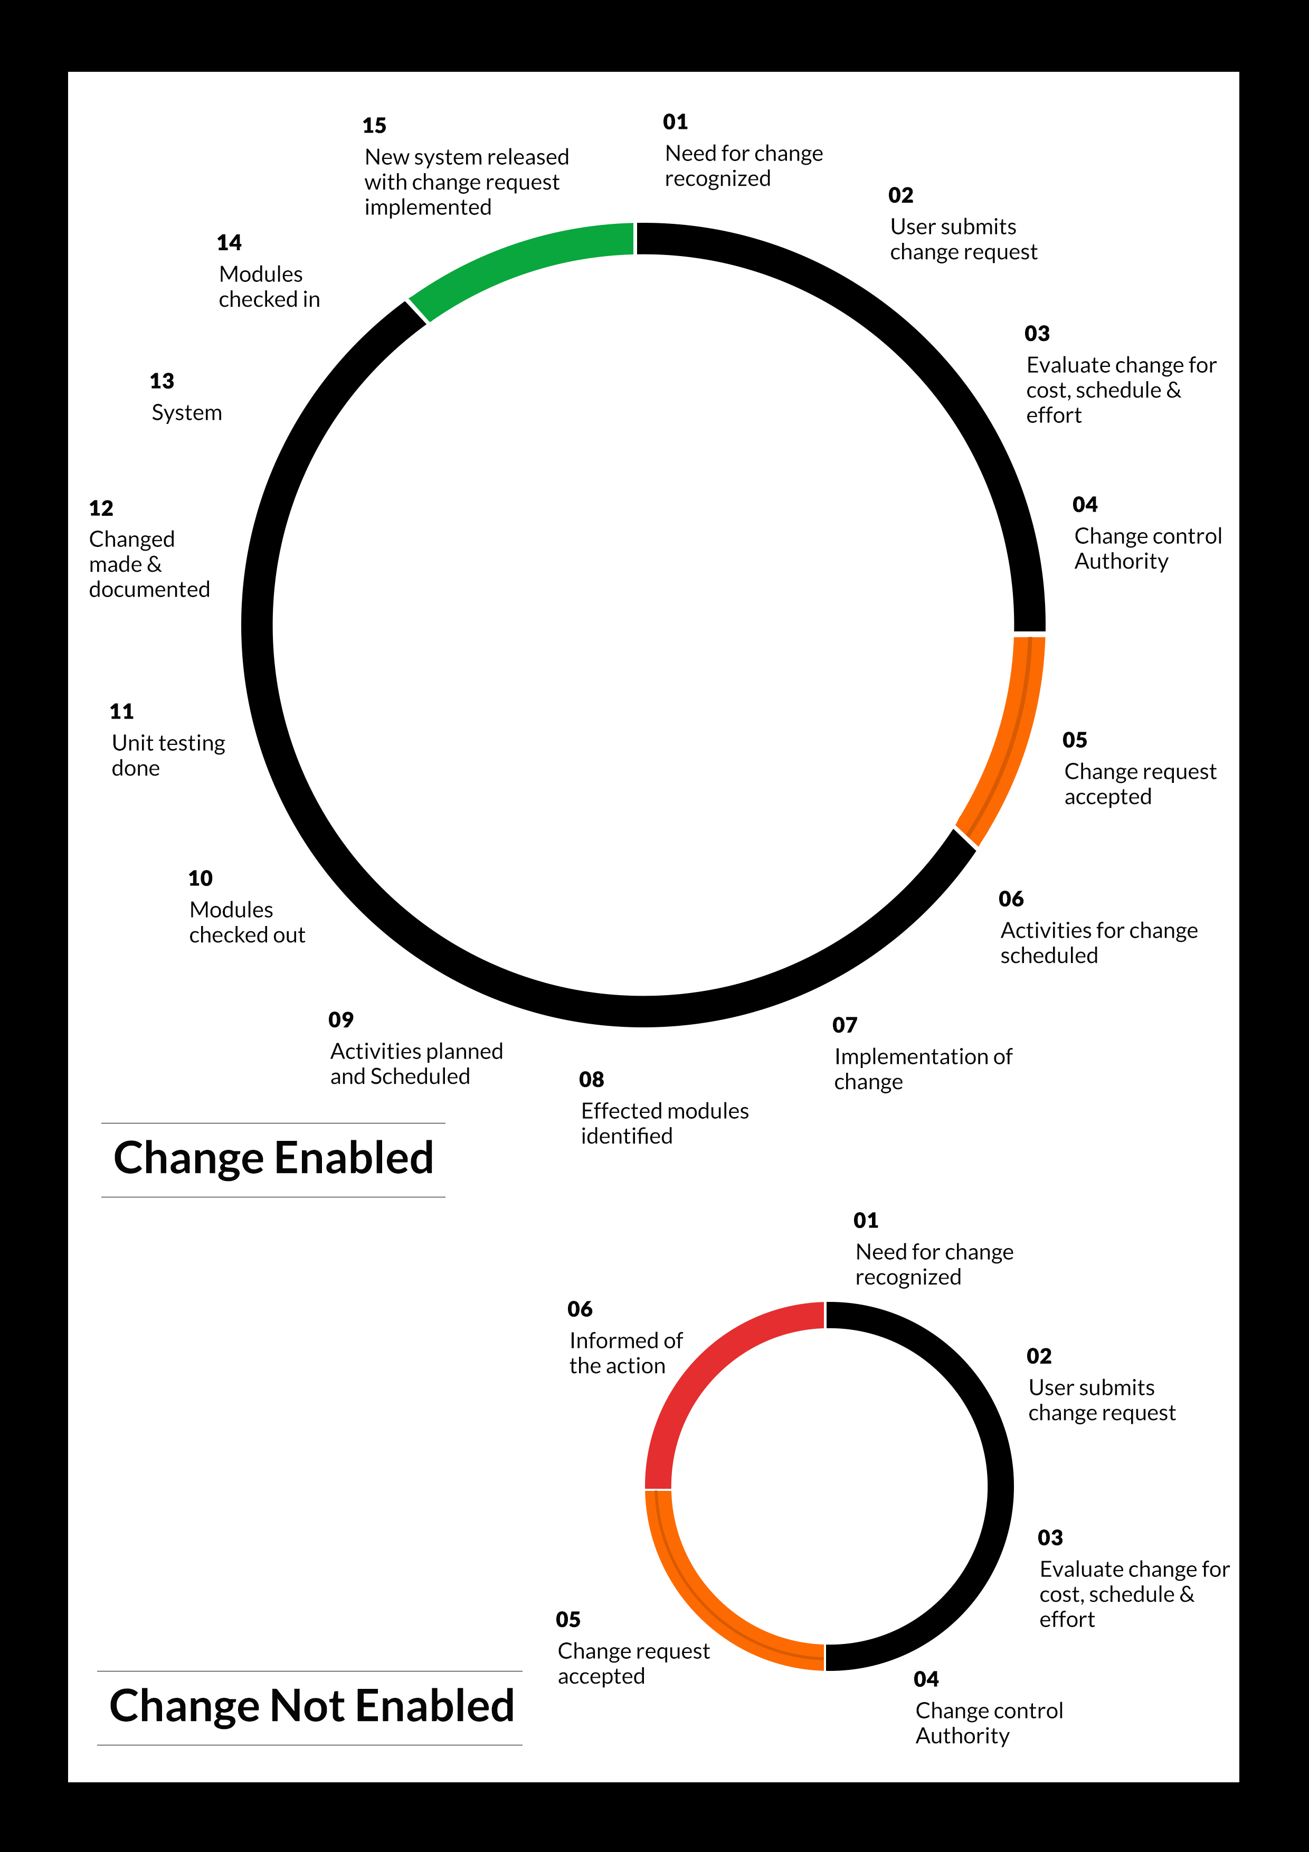

This section below is optional depending on agreement with client

## Maintenance & Support

* Maintenance contracts by default are supported as per the basic SLA terms.
* AMC with Basic SLA is charged at 25 % of the total project value. Additional Effort/change management request will be added towards Total Value of the Project to determine the AMC value.
* Maintenance support is limited to providing application support for ensuring the consistency of the look-and-feel, bug fixes and user issues i.e. maintenance and support of the existing features of the application.
* Support does not in any way cover providing technical or other support to the end users. The maintenance agreement does not include functionality changes or feature additions which are handled as change requests which will be charged AED 1,200.00 per man day. AMC does not include server support, maintenance and application deployment.
* AMC charges will cover Off-Site Support and Debugging. Support includes E-mail, Telephone and Chat unless explicitly specified. In the event, the application is hosted with the client; necessary remote desktop connectivity **should be** provided for carrying out maintenance activity.
* Gap in AMC - In case if the client does not opt an AMC for a year and want to renew it after that period, 50% of the AMC amount for the year for which AMC is not taken will also be payable if the client wishes to renew the AMC contract.

*Note:*

* *Please note that the AMC support shall start only after all the necessary sign-offs (AMC Document) to this effect have been given.*
* *It is not mandatory that the client* ***should*** *opt for an AMC (replace with perhaps : It is mandatory that the client opts for an AMC) . The client will still be supported on an ad-hoc basis on an agreed man-day rate.*
* *AMC Payment Terms: 100% to be paid as advance.*

## Service Level Agreement (SLA)

|  |  |  |  |  |
| --- | --- | --- | --- | --- |
| **SLA Type** | **Max Response Time** | | **Max Resolution Time** | **Target** |
| Basic | 1  working day | 3 working days | | Request / incident / problem tickets |
| Advanced | 5 Business Hours | 12 Business Hours | | Request / incident / problem tickets |
| Priority | 3 Business Hours | 5 Business Hours | | Request / incident / problem tickets |

*Note:*

* *We provide Basic SLA as standard with AMC while Advanced and Priority SLAs attract additional charges.*
* *Time zone applicable (8:00 am to 5.00 pm, Sunday to Thursday)*

AMC Option:

Client can opt for time and material based Annual Maintenance, the details of which will be shared post the completion of project.

# **Terms & Conditions**

## Acceptance Criteria

* UAT (User Acceptance Test) sign off **should** happen within 07 Days from the first release of the application and the acceptance confirmation needs to be mailed to Verbat failing which Verbat will consider the project as approved by the client.
* Any comments or reason for rejection need to be documented and the same needs

to be sent as an email from the official mail id of client to Verbat on or before 07 days

from the first release.

* Timeframe for acceptance for any further release will be mutually agreed and finalized between client and Verbat depending on the UAT Comments

## Warranty

* Verbat shall provide a bug ﬁx warranty at no additional cost for 30 days from the date of acceptance of the project, for correction of any errors in the developed application that may be attributed to Verbat.
* However, this does not cover modifications by Client, or use of the application on an environment other than the proposed environment, or other circumstances outside Verbat’s reasonable control. In such a case Verbat reserves the right to charge for its services.
* All error corrections will be executed at Verbat India office. In the event of any need for on-site work, all expenses incurred for such trips will be payable to Verbat by Client.

## Source Code & Intellectual Property Rights

* Upon completion of the Project and 100% completion of the payment, client will have access to the source code except for propriety codes, developer tools and third party applications **etc.**
* The solution offered will be the intellectual property of the client and will be made available to the client on an “unlimited license” basis.
* Modifications by third party/person: No person or organization, other than Verbat or any person authorized by Verbat in writing, has any permission to modify/change the software Solution to be eligible to get continued support from Verbat as per the support terms defined under this document.
* Liabilities/Damages: Verbat accepts no liability or damages of any kind arising out of use or non-use of the software delivered. The responsibility of testing of software lies with Client.

## General Terms and Conditions

* Offer Valid for 30 calendar days from the date of submission of the Proposal.
* An average of 20 working days are assumed in a month.
* All the projects activities will be carried out from our off-shore development center in India
* All the documentation will be provided in English.
* Third party components may be used to develop this application.
* The scope of the project is to develop the Application as detailed in the scope of the project and mentioned in this proposal. Any changes or additions will have to go through change management.
* This proposal **would** have been derived or concluded from either the RFQ /RFP/data shared via email / information transferred during an initial requirement analysis meeting / tele-conversation. Verbat reserves the right to change the terms of this proposal as the final terms (including the costing), features & functionalities and timeline could change during the course of the project. Hence any fees quoted / timeline committed in this proposal may not be considered as final unless agreed and signed by both parties.
* Web Application will be best viewed only in the environment mentioned in the section Browser Compatibility
* Mobile app will be best viewed only in the environment mentioned in the section Hardware Interface
* All Source Codes and other project artefacts **would** adhere to the Verbat document templates and internal coding standards.
* The documents delivered to the client includes the ones mentioned under ‘Deliverables’ and these will adhere to Verbat’s internal document standards.
* Acceptance criteria shall be based on the clauses which were mutually discussed between Verbat and client at the Requirement Analysis phase and the same will be documented and approved by both parties through official emails
* In case Client requires any extension of the proposed acceptance schedule, the associated effort and cost of such extension can be mutually reviewed.
* For any circumstances if project needs to be put on Hold / Stop it requires minimum request notice period of 1 week along with duration for which request will be addressed by management and final decision on the request will be based on that
* If deployment is done in client’s server, Verbat cannot be held responsible for any performance issues arising due to hardware malfunctions.
* Client is responsible for data backup in case the application is not hosted on Verbat server.
* Source code will only be delivered or uploaded on the Production Server once the due payments are made.

## General Administrative, Technical & Functional Assumptions

* Detailed system study is required before the start of the project.
* During the requirement gathering phase, authorized personnel from the Client’s side is expected to be available for discussion and finalizing the HLD (High Level Design), before development commences.
* Type of reports and formats, if under the scope of the project, needs to be specified by Client before project sign off.
* Workflows if under the scope of the project, need to be specified/ confirmed by client before project signoff.
* Verbat assumes that all sign-offs from Client will be provided within agreed and specified timeframe.
* Client will provide all the necessary contents, both text and image, before starting the project in the format suggested by Verbat (if any).
* The client **should** provide the relevant information and data well in time for the execution of a related activity. Non- availability of this information or data may lead to an interruption of work which may result in a delay in delivery as well as additional costs to the client.
* Client **should** have/possess server with technical specifications as suggested by Verbat for the proposed application.
* Client will be provided with one time training (train the trainer) on how to use the application via video conference (maximum of 4 hours). Additional training requests will be charged.

# **FINANCIALS.**

## Web and Mobile Application Development

|  |  |  |
| --- | --- | --- |
| **No** | **Description** | **Amount (AED)** |
| 01. | Development of:   * Web Application for Super admin, Site Admin, Resolver and Viewer * Android Mobile Application for Patrol users * Active Directory Integration for user authentication |  |
|  | **Total Project Cost** |  |

*Note:*

* *The above cost is exclusive of VAT applicable in UAE*
* *The above cost is based on the initial understanding of the requirement grounded on the details shared by client. Any further changes in the scope or complexity if encountered during detailed system study/ analysis will call in for additional effort and time.*
* *The above cost does not include Application hosting, integration with any other third-party systems, deployment unless explicitly mentioned in this proposal.*
* *For feature additions, please refer section titled “Change Management “.*
* *LPO to be raised in the name of “Verbanet Technologies LLC” for project initiation*
* *Refer section 7.3 for ‘Mode of Payment’.*

### Payment Terms

* 30% () of total project value to be paid as advance along with the Purchase Order
* 40% () of total project value to be paid on confirmation of the UI/UX
* 30% () of the total project value to be paid on completion of Development and UAT on Verbat test server

*Note:*

*Payment should be made within 7 days from the date of invoice.*

## Windows Dedicated Hosting – Optional

ITEM NO. DECSRIPTION AMOUNT (AED)

1. Windows Dedicated Hosting

TOTAL PROJECT COST

*Note:*

* *The above cost is exclusive of VAT applicable in UAE*
* *Refer “Windows Dedicated Hosting Proposal” for detailed Server specifications.*
* *Refer section 7.3 for ‘Mode of Payment’.*
* *LPO to be raised in the name of “Verbanet Technologies LLC” for project initiation*

### Payment Terms

* 100% advance payment along with Purchase Order to initiate Server purchase

*Note:*

*Payment* ***should*** *be made within 7 days from the date of invoice.*

### Mode of Payment

By Cheque to Verbanet Technologies LLC

OR

Wire transfer to our bank account

Bank Name : Emirates NBD

Account Name : Verbanet Technologies LLC

Account Number : 1011492858201

IBAN Number : AE61 0260 0010 1149 2858 201

Swift Code : EBILAEAD

Bank Address : Mamzar Branch, Dubai

*Note:*

* *Bank charges incurred during wire transfer to be borne by the client.*
* *Any local taxes / VAT applicable to be borne by the client*
* *Client invoices will include VAT charges in addition to the application cost*

# **About Us**

Education

Transportation



Please add our latest brochure pages here – except page 2

Shibu – your support is needed here please

A quick and rough cut and paste already attached

Please format neatly – so it sits in the body of the page

Ensuring all the latest pages only..

Charts which are colour heavy like the one below need to be reversed and put into a colour scheme where black and orange is minimized

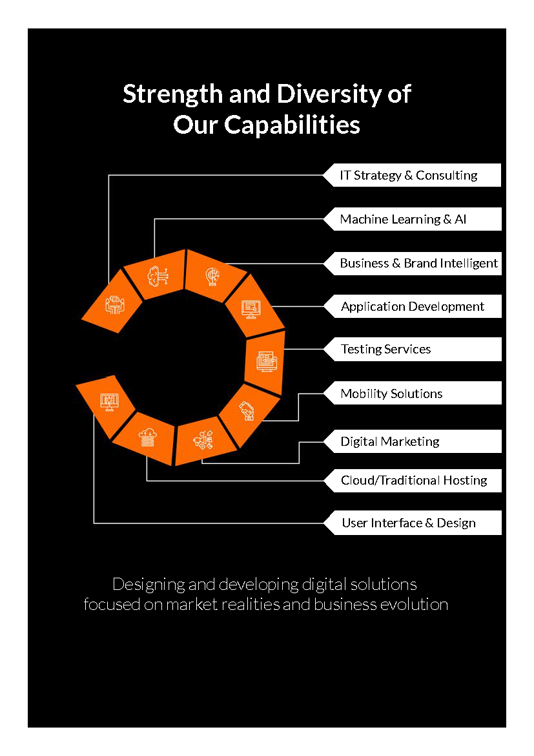

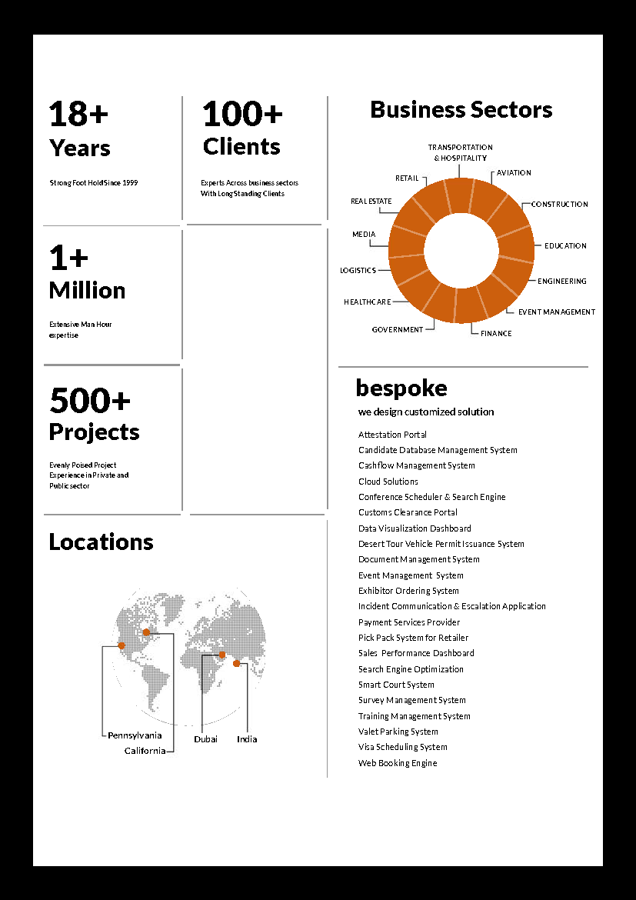



**Conﬁdentiality Notice:**

**This Proposal is conﬁdential and contains proprietary information and intellectual property of Verbanet Technologies LLC. Neither this proposal nor any of the information contained herein may be reproduced or disclosed under any circumstances without the express written permission of Verbanet Technologies L.L.C (hereby known under its brand name of Verbat in the United Arab Emirates). 2018. All rights Reserved**

# Glossary Of Terms

Education

Transportation

Here a new section to be added with all the key words, terms etc that are commonly used in our document sfor the general benefit of the client and the non-technologically aligned readers – client side.